

Requirement & Design Specification

**Land Auction**

**Version: 2.0**

– Hanoi, October 2024 –

# Record of Changes

| **Version** | **Date** | **A* M, D** | **In charge** | **Change Description** |
| --- | --- | --- | --- | --- |
| V1.0 | 15/9 | A | ChungLDD, TuNA, TungPV | Add Use case diagram, use case description. |
| V1.1 | 01/10 | A | ChungLDD, TuNA, TungPV | Add Screen Flow, Context Diagram,System Function, Functional Requirement |
| V1.2 | 12/10 | A | ChungLDD, TuNA, TungPV | Add entity relationship diagram |
| V1.3 | 15/10 | M | ChungLDD, TuNA, TungPV | Update Context Diagram, Screenflow |
| V1.4 | 17/10 | A | ChungLDD, TuNA, TungPV | Add Function Requirements |
| V1.5 | 20/10 |  | ChungLDD, TuNA, TungPV | Docs II.Requirement Specifications (Role: Admin, Staff) |
| V1.6 | 23/10 | A,M | ChungLDD, TuNA, TungPV | Add, Modify Function Requirements, Modify ScreenFlow |
| V1.7 | 27/10 | M | ChungLDD, TuNA, TungPV | Update Use Case |
| V2.0 | 29/10 | A,M | ChungLDD, TuNA, TungPV | Add, Modify Business Rule |

*A - Added M - Modified D - Deleted

# Table of Contents

Record of Changes 2

**Table of Contents 3**

I. Overview 7

1. User Requirements 7

1.1 Actors 7

1.2 Use Cases 7

2. Overall Functionalities 15

2.1 Screens Flow 15

2.2 Screen Descriptions 15

2.3 Screen Authorization 17

2.4 Non-UI Functions 19

3. System High Level Design 20

3.1 Database Design 20

3.2 Code Packages 22

II. Requirement Specifications 23

1. Common Functions 23

UC-11_Login 23

UC-14_Logout 24

UC-13_Forgot password 25

UC-08_View profile 26

UC-09_Edit profile 27

UC-10_Change password 28

2. Public Functions 29

UC-12_Register User Account 29

UC-05_View Website’s Information 31

UC-06_View Published News List 32

UC-07_View Published News’ Details 33

UC-22_Search Auction (public) 34

UC-39_Search news 35

UC-01_View Auction List 36

UC-02_View Auction’s Detail 37

UC-17_Chat with Chat Bot 37

3. Customer’s Functions 39

UC-03_Register auction session 39

UC-04_Place Bid 40

UC-15_Register Asset Validation 41

UC-38_View individual registered assets list 42

UC-38_View individual registered assets list 42

UC-16_Withdraw Auction Asset Registration Request 43

UC-18_View Balance 44

UC-21_Withdraw from Wallet 45

UC-19_Deposite Payment (winner) 46

UC-20_Top up from Wallet 47

UC-66_Pay registration fee 48

UC-37_Join an auction session 49

UC-67_View payment history 50

4. Staff’s Functions 51

UC-26_View news list 51

UC-27_View news detail 52

UC-28_Create news 53

UC-29_Update news (personal) 54

UC-30_Delete news (personal) 55

UC-31_View Validated Assets 56

UC-33_View Waiting Validation Requests 57

UC-32_View Asset’s Details 58

UC-36_View customer registered to join auction 59

UC-35_Schedule auction 60

UC-34_Validate Asset 61

UC-40_Search asset 62

UC-41_Search news 63

UC-42_Search auction 64

UC-57_View Topic List 64

UC-58_View Topic Detail 65

UC-59_Add Topic 66

UC-60_Update Topic 67

UC-61_Delete Topic 68

UC-62_View Answer List 68

UC-63_Add Answer 69

UC-64_Update Answer 70

UC-65_Delete Answer 71

UC 68-View auction list 72

UC-69_View auction’s detail 73

5. Administrator’s Functions 74

UC-24_Create Staff account 74

UC-23 _Ban Account 75

UC-25_Validate account 76

UC-43_View customer’s account list 77

UC-44_View account detail 78

UC-45_View waiting to verified account list 79

UC-46_Search account 80

UC-47_View staff’s account list 81

III. Design Specifications 82

1. Public screen 82

1.1 Sign in 82

1.2 Sign up 84

1.3 Forget Password 85

1.4 Homepage 86

1.5 Website Information 88

1.6 New list 89

1.7 New detail 90 91

1.9 View asset list 93

1.10 View auction list 94

1.11 View auction detail 96

1.12 View asset detail 97

1.13 Register Auction Session 98

1.14 View asset register list 100

1.15 View asset register list 101

1.16 View User profile 102

1.17 View User Wallet 105

1.18 Withdrawal Wallet 106

1.19 Top up money from wallet 107

1.20 Join ongoing auction 108

1.21 Pay deposit winner 110

1.22 Pay auction registration fee 111

1.23 Pay asset form 112

1.24 Pay asset form 114

2. Staff Screen 115

2.1 View all news 115

2.2 View own news 117

2.3 View news detail 119

2.4 Create news 120

2.5 Update news 121

2.6 View asset list 122

2.7 View asset detail 123

2.8 View auction list 124

2.9 View auction detail 126

2.10 View asset awaiting scheduling list 128

2.11 Validate asset 130

2.12 Schedule auction 132

2.13 Chatbot Management 134

3. Admin’s screen 137

3.1 Staff’s Account Management 137

3.2 User’s Account Management 139

3.3 Account’s Details 140

3.4 Create user/staff account 142

IV. Appendix 144

1. Assumptions & Dependencies 144

1.1 Assumptions 144

1.2 Dependencies 144

2. Limitations & Exclusions 145

3. Business Rules 145

4. Exception list 146

# I. Overview

## 1. User Requirements

### 1.1 Actors

| **#** | **Actor** | **Description** |
| --- | --- | --- |
| 1 | Guest | Users access the system without logging in. Only have the right to view some basic information that the system allows to be displayed publicly |
| 2 | Customer | Users who have registered, can participate in trading, auctions, and other advanced features |
| 3 | Customer care | User who manage news create news for website |
| 4 | Staff | Internal users of the system, have access to data necessary to perform work but are restricted to high-level administrative operations |
| 5 | Administrator | The person who have responsibility for managing user and employee accounts |

### 1.2 Use Cases

#### a. Diagram(s)

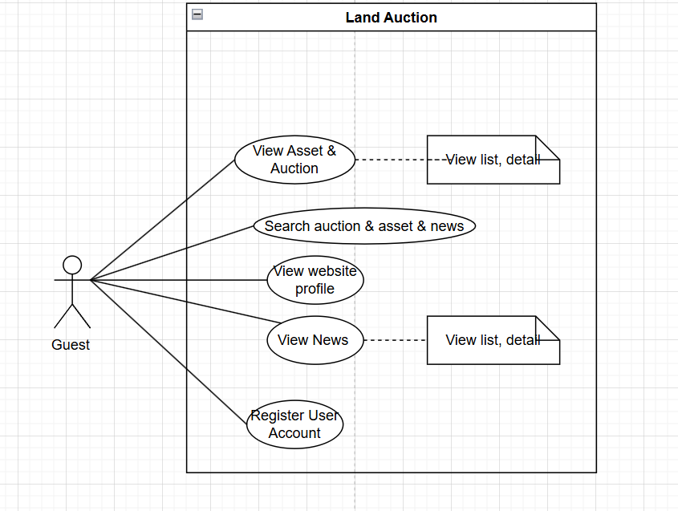

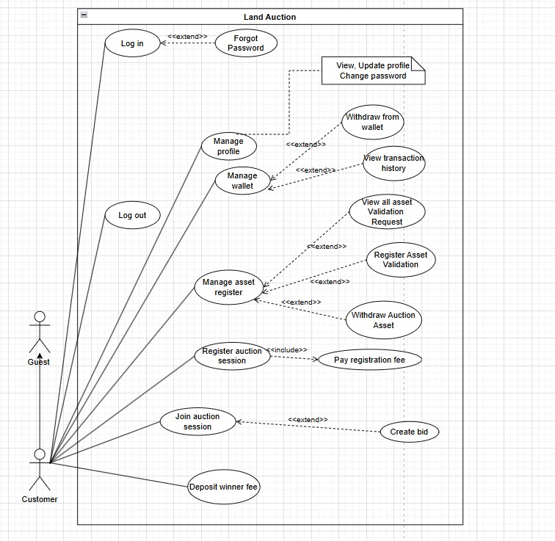

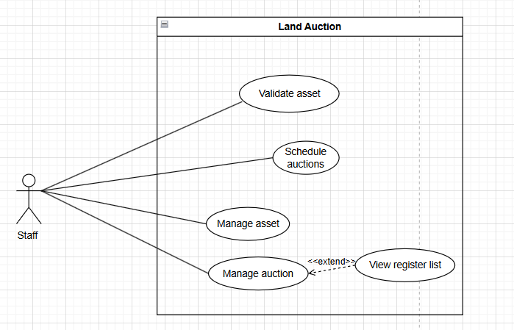

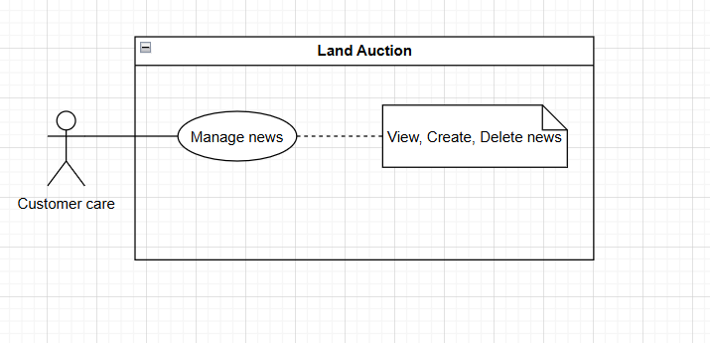

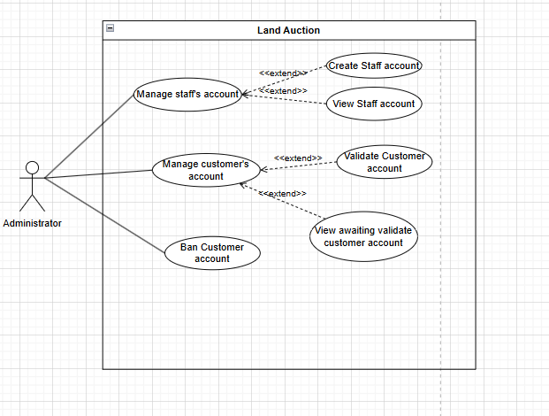

#### b. Descriptions

| **ID** | **Feature** | **Use Case** | **Use Case Description** |
| --- | --- | --- | --- |
| UC_01 | Common functions | Login | User login into the system by email |
| UC_02 | Common functions | Logout | A User logs out of the website, terminating their session and ensuring their account security. |
| UC_03 | Common functions | Forgot-password | Allows users to recover their password if forgotten. |
| UC_04 | Common functions | View profile | Allows a registered user to view their profile information |
| UC_05 | Common functions | Edit profile | User can update or edit their profile in the website |
| UC_06 | Common functions | Change password | Users can change their password and they can ensure the security account. |
| UC_07 | Public functions | Register account | A guest could register a new user account to perform further actions on the website. |
| UC_08 | Public functions | Website’s information | The user could view all the information about the website. |
| UC_09 | Public functions | News list | Users could view the list of news published on the website. |
| UC_10 | Public functions | News detail | Users could read more about a specific published news. |
| UC_11 | Public functions | Search news | Users could search for the news |
| UC_12 | Public functions | Auction list | Users could view the list of auctions. |
| UC_13 | Public functions | Auction detail | Users could view an auction’s details. |
| UC_14 | Public functions | Search auction | Users could search for the auction. |
| UC_15 | Customer’s functions | Register auction session | Customers could register to participate in an auction. |
| UC_16 | Customer’s functions | Join auction session | Register customer can join to auction session and view the detail information of ongoing auction |
| UC_17 | Customer’s functions | Create bid | Customers could place a bid during an auction session. |
| UC_18 | Customer’s functions | History join auction | Customer can see all auction that he/she registered to the system |
| UC_19 | Customer’s functions | Wishlist | Customers can see all auctions that he/she care. |
| UC_20 | Customer’s functions | Register asset | The customer registers asset validation to auction. |
| UC_21 | Customer’s functions | View asset history | Customer can see all assets that he/she registered to the system |
| UC_22 | Customer’s functions | Cancel asset | Allows the customer to withdraw Asset Registration Request when it is in a withdrawable state. |
| UC_23 | Customer’s functions | Withdraw money | Customers could withdraw funds from their personal wallet. |
| UC_24 | Customer’s functions | Deposit auction register | Customers could make a deposit payment for an auction session. |
| UC_25 | Customer’s functions | Deposit asset register | Customers could make a deposit payment for an asset register. |
| UC_26 | Customer’s functions | View transaction history | The customer could see all transaction they have done before in the website |
| UC_27 | Customer care’s function | View news list | Customer care can read all the news has posted on system |
| UC_28 | Customer care’s function | View Own news | Customer care can read all the news he/she has posted on system |
| UC_29 | Customer care’s function | View news detail | Customer care can be able to view the news detail which he/she is author, so that I can read that news |
| UC_30 | Customer care’s function | Create news | The Customer care be able to create news to the system |
| UC_31 | Staff’s function | View list auction | Staff could view the list of auctions. |
| UC_32 | Staff’s function | View auction detail | Staff could view an auction’s details. |
| UC_33 | Staff’s function | Schedule auction | The staff be able to schedule auction according to a suitable timeline |
| UC_34 | Staff’s function | View list asset register | Allows the customer to view a list of assets that are waiting for validation. |
| UC_35 | Staff’s function | View asset detail | The staff could view details of the asset. |
| UC_36 | Staff’s function | Cancel asset |  |
| UC_37 | Staff’s function | Validate asset | Staff reviews and validates assets uploaded by clients for auction purposes. |
| UC_38 | Admin’s function | Performance statistic | Allow admin views analyze, statistic and total auction, asset,.. in system |
| UC_39 | Admin’s function | Views account list | Admin view list of account |
| UC_40 | Admin’s function | Views account violation | Admin view list of violation account |
| UC_41 | Admin’s function | Views account validate | Enables the Admin to view a list of customer accounts that are pending verification and validation. |
| UC_42 | Admin’s function | Ban account | Admin can ban accounts user or staff who violates the term |
| UC_43 | Admin’s function | Unban account | Admin can unban accounts user or staff |
| UC_44 | Admin’s function | Create staff, customer care account | Admin can create new staff account for new staff in the company to login system |
| UC_45 |  | Validate account | Admin validate user accounts to ensure they meet all requirements and are authorized for system access. |
| UC_46 |  | Account detail | Enables the Admin to view a detail of customer accounts in the system. |
| UC_47 |  |  |  |
| UC_48 |  |  |  |
| UC_49 |  |  |  |

## 2. Main workflows

## 3. Overall Functionalities

### 3.1 Screens Flow

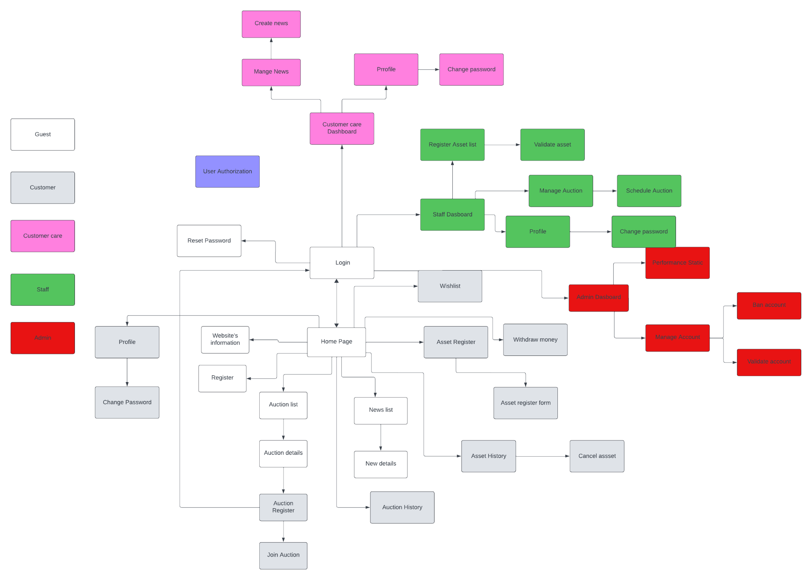

### 3.2 Screen Descriptions

| **#** | **Feature** | **Screen** | **Description** |
| --- | --- | --- | --- |
| 1 |  | Home page | The first page when a user accesses the website. |
| 2 | View web’s information | Website’s information | Allow user to see the website’s information. |
| 3 | News | New List | Allow the user to see published news on the website. |
| 4 | News Detail | News Detail | Allow the user to see published news’ details on the website. |
| 5 | User register | User register | Allow the user to register a new customer account. |
| 6 | User login | User login | Allow the user to login to the website. |
| 7 | Forgot password | Forgot password | Allow the user to change the password of his/her account. |
| 8 | Change password | Change password | Allow the user to see public auctions sessions. |
| 9 | Profile | Profile | Allow the user to see and update the personal information. |
| 10 | View auction list | Change password | Allow the user to change the password. |
| 12 | Withdraw from the wallet | Withdraw from the wallet | Allow user to withdraw money from system to personal bank account |
| 13 | Register Auction Session | Register auction session | Allow user to register to exist auction session |
| 14 | Pay Auction registration fee | Pay Auction registration fee | Allows users to pay the required fee to register for an auction. |
| 15 | Join ongoing auction session | Join ongoing auction session | Enables registered users to participate in an active auction session. |
| 17 | Create news | Create news | Allows staff to create a new article, including title, content, and other details. Users can upload images or attach documents. |
| 16 | Auction history | Auction history | Allows users to see their history join auction |
| 18 | News list | View news list | Displays a list of published articles with title, creation date, and author. Users can search, sort, or filter the list by various criteria. |
| 19 | News detail | View news detail | Shows the full content of an article, including attached images and author information. Users can review or edit content if permitted. |
| 20 | Views own news | Views own news list |  |
| 21 | Delete news | Delete news | Provides an option to delete an article from the list. Users are prompted to confirm the action to prevent accidental deletion. |
| 22 | Asset Awaiting Scheduling | List asset awaiting scheduling | Displays assets that are pending auction scheduling. Users can view details and initiate scheduling actions. |
| 23 | Validate asset | Validate asset | Allows staff to review and approve assets for auction. Users can view submitted documents and validate asset information. |
| 24 | Schedule auction session | Schedule auction session | Enables staff to set up auction sessions, including scheduling date, time, and relevant asset details. |
| 35 | Account management | Account management | Enables management Accounts, including viewing, activating, deactivating, and assigning roles. |
| 26 | Create staff account | Create staff account | Allows the creation of new staff accounts with necessary information, such as username, role, and permissions. |
| 27 | View account detail | Account detail | Displays detailed information about a specific account, including personal details, role, and account status. |
| 28 | Wishlist | Wishlist | Allows users to mark and save auctions or assets they are interested in for future reference. |
| 29 | Asset register | Asset register | Enables users to submit their assets for auction registration, including required details and documentation for approval. |
| 30 | Performance statistic | Performance statistic | Provides performance metrics and staff evaluate the system's efficiency and user engagement. |
| 31 | Ban account | Ban account | Allows administrators to restrict or ban user accounts based on violations or misconduct within the platform. |
| 32 | Validate account | Validate account | Involves the verification and validation of user accounts to ensure authenticity or compliance checks. |

### 3.3 Screen Authorization

| **Screen** | **Guest** | **Customer** | **Customer care** | **Staff** | **Admin** |
| --- | --- | --- | --- | --- | --- |
| Home page | X | X | X | X | X |
| Login | X | X | X | X | X |
| Register | X |  |  |  |  |
| Forgot password |  | X | X | X | X |
| Website information | X | X | X | X | X |
| New list | X | X | X | X | X |
| New detail | X | X | X | X | X |
| Auction session list | X | X | X | X | X |
| Auction session detail | X | X | X | X | X |
| Wishlist |  | X |  |  |  |
| Register auction session |  | X |  |  |  |
| Pay auction fee |  | X |  |  |  |
| Join ongoing auction session |  | X |  |  |  |
| Pay deposit winner |  | X |  |  |  |
| Asset register list |  | X |  | X |  |
| Cancel Asset Registration |  | X |  |  |  |
| Register Asset form |  | X |  |  |  |
| Asset Registration fee detail |  | X |  |  |  |
| Profile |  | X | X | X |  |
| Change password |  | X | X | X | X |
| Withdraw Money |  | X |  |  |  |
| Staff dashboard |  |  |  | X |  |
| List Asset awaiting scheduling |  |  |  | X |  |
| Validate asset |  |  |  | X |  |
| Scheduling auction session |  |  |  | X |  |
| Create news |  |  | X |  |  |
| View news list |  |  | X |  |  |
| Delete news |  |  | X |  |  |
| View news detail |  |  | X |  |  |
| Admin dashboard |  |  |  |  | X |
| Ban account |  |  |  |  | X |
| Create staff account |  |  |  |  | X |
| Validate account |  |  |  |  | X |
| Account detail |  |  |  |  | X |

Table - User Authorization

In which:

* Guest: The user that has not yet registered an account.
* Customer: A registered user who has created an account and can participate in system activities, such as bidding.
* Customer care: User for creating and publishing news content within the system, keeping users informed of updates, events, and important announcements.
* Staff: Employees of the system who handle specific duties, such as auction management, customer service, and validation of assets.
* Admin: Individuals responsible for managing and overseeing the system, including user and staff management, and configuration.

### 3.4 Non-UI Functions

### 

| **#** | **Feature** | **System Function** | **Description** |
| --- | --- | --- | --- |
| 1 | Common | Sign out | Users sign out of the system |
| 2 | Common | Authorization | This is the authorization mechanism in the system |

## 3. System High Level Design

### 3.1 Database Design

#### a. Database Schema

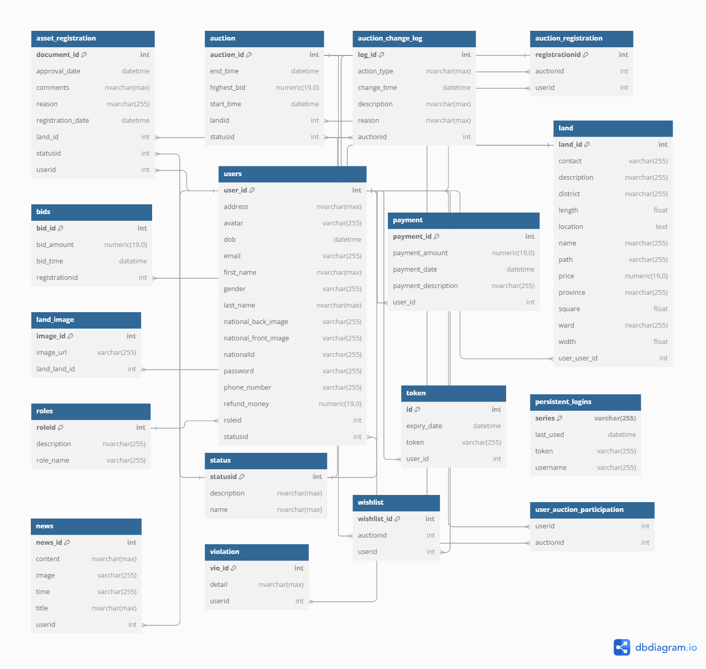

#### b. Table Descriptions

### 

| **No.** | **Table** | **Primary Key** | **Foreign Keys** |
| --- | --- | --- | --- |
| 01 | Role | roleid | None |
| 02 | Users | user_id | roleid (references Role.roleid), status_id (references Status.status_id) |
| 03 | Status | statusid | None |
| 04 | Asset Registration | document_id | user_id (references Users.user_id), land_id (references Land.land_id), status_id (references Status.status_id) |
| 05 | Land | land_id | user_user_id (references Users.user_id) |
| 06 | Auction | auction_id | landid (references Land.land_id), statu_sid (references Status.status_id) |
| 07 | Auction Change Log | log_id | auctionid (references Auction.auction_id) |
| 08 | Auction Registration | registration_id | auctionid (references Auction.auction_id), user_id (references Users.user_id) |
| 09 | Bids | bid_id | registrationid (references Auction Registration.registrationid) |
| 10 | Land Image | image_id | land_land_id (references Land.land_id) |
| 11 | News | news_id | use_rid (references Users.user_id) |
| 12 | Payment | payment_id | user_id (references Users.user_id) |
| 13 | Persistent Logins | series | None |
| 14 | Token | id | user_id (references Users.user_id) |
| 15 | User Auction Participation | user_id, auction_id | user_id (references Users.user_id), auction_id (references Auction.auction_id) |
| 16 | Violation | vio_id | user_id (references Users.user_id) |
| 17 | Wishlist | wishlist_id | user_id (references Users.user_id), auction_id (references Auction.auction_id) |

#### 

### 3.2 Code Packages

#### a. Packages Schema

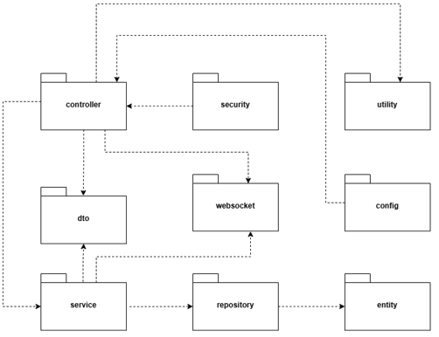

#### b. Package descriptions

| **No** | **Package** | **Description** |
| --- | --- | --- |
| 01 | security | Contains classes and configurations related to security, authentication, authorization, encryption, etc. |
| 02 | controller | Handles HTTP requests from users, manages endpoints for APIs or user interfaces. |
| 03 | utility | Contains general processing logic that supports utilities in the application, such as data conversion, formatting. |
| 04 | dto | Contains data conversion between client and server, often used in data transmission. |
| 05 | service | Contains the application's business logic, handles key tasks based on controller requests. |
| 06 | repository | Manages queries and database operations, used to store and retrieve data. |
| 07 | entity | Contains classes that represent tables in the database, defining the application's data structure. |
| 08 | websocket | Handles subsequent transaction execution, uses WebSocket to continuously exchange data with clients. |
| 09 | config | Contains configurations for the application, such as database configuration, security, WebSocket configuration, etc. |

# II. Requirement Specifications

## 1. Common Functions

### UC-01_Login

#### 

| UC ID and Name: | **UC-01_Login** | | |
| --- | --- | --- | --- |
| Created By: | ChungLDD | Date Created: | 01/10/2024 |
| Primary Actor: | Customer, Staff, Admin, Customer care | Secondary Actors: |  |
| Trigger: | User selects the "Login" option from the login page, sidebar, or directly accesses the login URL. | | |
| Description: | User login into the system by account or email | | |
| Pre-conditions: | PRE-1: The user must have an existing and authorized account.  PRE-2: The user's device is connected to the internet. | | |
| Post-conditions: | POST-1: The user is logged in successfully and gains access to the system's features.  POST-2: The system records the login attempt. | | |
| Normal Flow: | **01.0 Login**   1. User accesses the website's login page. 2. User enters their email and password. 3. User clicks the “Login” button. 4. The system verifies the login credentials.(**See 01.1**) 5. If the credentials are valid, the user is granted access to the system. 6. The system records the successful login. | | |
| Alternative Flows: | **01.1:**   1. User enters an incorrect email or password and clicks "Login." 2. System detects invalid credentials. 3. System displays an error message, prompting the user to re-enter correct information. | | |
| Exceptions: | **Message-E004**: **Network failure**  The system cannot communicate with the server – An error message is displayed.  **Message-E001: No exist data**  Username does not exist – An error message prompts the user to check their username.  **Message-E001: No exist data**  Incorrect password – An error message prompts the user to re-enter the password. | | |
| Priority: | High | | |
| Frequency of Use: | High | | |
| Business Rules: | **BR1, BR3** | | |
| Other Information: | N/A | | |

### UC-02_Logout

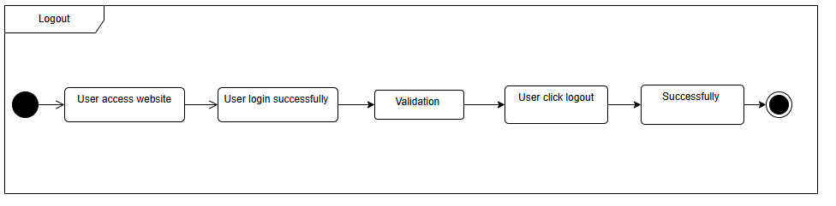

| UC ID and Name: | **UC-02_Logout** | | |
| --- | --- | --- | --- |
| Created By: | ChungLDD | Date Created: | 01/10/2024 |
| Primary Actor: | Customer, Staff, Admin, Customer care | Secondary Actors: |  |
| Trigger: | User indicates to log out the system | | |
| Description: | A User logs out of the website, terminating their session and ensuring their account security. | | |
| Pre-conditions: | PRE-1: User accesses the system.  PRE-2: User is currently logged in. | | |
| Post-conditions: | POST-1: View home page as guest  POST-2: Login, register,.. | | |
| Normal Flow: | **02.0 Logout** 1. On the user screen, select the menu in the upper right  corner.  2. Click “Logout”.  3. The system will redirect user to the login page. | | |
| Alternative Flows: | N/A | | |
| Exceptions: | **Message-E006**: **Session Timeout**  Redirect the user to the login page with a message indicating that the session has expired.  **Message-E004**: **Network failure**  Display an error message indicating the logout attempt failed due to a network issue. The user should try again once the network is stable. | | |
| Priority: | High | | |
| Frequency of Use: | High | | |
| Business Rules: |  | | |
| Other Information: | N/A | | |

### UC-03_Forgot password

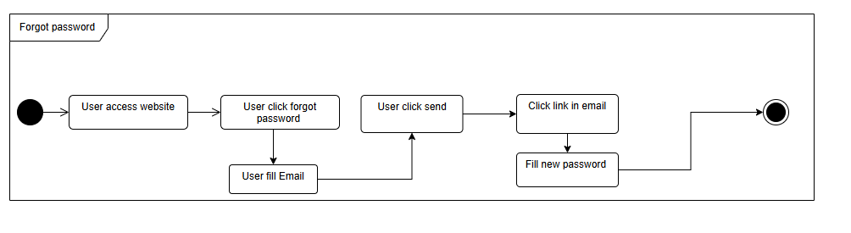

| UC ID and Name: | **UC-03_Forgot password** | | |
| --- | --- | --- | --- |
| Created By: | ChungLDD | Date Created: | 01/10/2024 |
| Primary Actor: | Customer, Staff, Admin, Customer care | Secondary Actors: | Gmail |
| Trigger: | User selects the "Forgot Password" option on the login page. | | |
| Description: | Allows users to recover their password if forgotten. | | |
| Pre-conditions: | PRE-1: The user must have an existing account in the system | | |
| Post-conditions: | POST-1: The user receives an email with a link to reset their password. | | |
| Normal Flow: | **03.0 Forgot Password**   1. On the login page, the user clicks the "Forgot Password" link. 2. The system displays a page asking the user to enter their registered email. 3. The user enters their email and clicks the "Submit" button. 4. The system checks if the email exists in the database. 5. If the email exists, the system sends a password reset link to the user's email. (see **03.1**) 6. The user accesses their email and clicks on the password reset link. 7. The system directs the user to a page to enter a new password. 8. The user inputs and confirms the new password, then clicks "Confirm." 9. The system updates the password and displays a success message. | | |
| Alternative Flows: | **03.1** If the user enters a non-existing email, the system displays an error message and prompts the user to re-enter the email. | | |
| Exceptions: | **Message-E004**: **Network failure**  The system cannot communicate with the server  **Message-E003**: **Not valid data**  Invalid email in the database or not exist  The system will display an error message | | |
| Priority: | High | | |
| Frequency of Use: | Occasionally | | |
| Business Rules: |  | | |
| Other Information: | N/A | | |

### UC-04_View profile

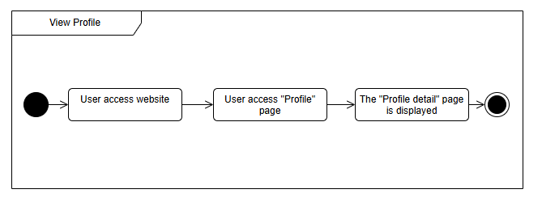

| UC ID and Name: | **UC-04_View profile** | | |
| --- | --- | --- | --- |
| Created By: | ChungLDD | Date Created: | 01/10/2024 |
| Primary Actor: | Customer, staff, customer care | Secondary Actors: |  |
| Trigger: | Users select the "Profile" option from their account settings. | | |
| Description: | Allows a registered user to view their profile information | | |
| Preconditions: | PRE-1: User is on the login page. | | |
| Postconditions: | POST-1: The user’s profile information is displayed on the screen. | | |
| Normal Flow: | **04.0 view profile**  1.The user selects the "Profile" option from the navigation menu.  2.The system retrieves the user's profile data from the database.  3. The system displays the user's profile details, including name, email, contact information, and other relevant information.. | | |
| Alternative Flows: | **04.1**: If the profile data is unavailable or corrupted, the system displays a message: "Profile information is currently unavailable." | | |
| Exceptions: | **Message-E004**: **Network failure**  The system cannot retrieve data from the database due to a server error – An error message is displayed, and the user is prompted to try again later. | | |
| Priority: | Medium | | |
| Frequency of Use: | Normal | | |
| Business Rules: |  | | |
| Other Information: | N/A | | |

### UC-05_Edit profile

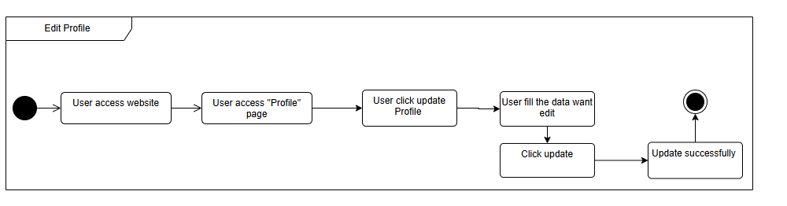

| UC ID and Name: | **UC-05_Update profile** | | |
| --- | --- | --- | --- |
| Created By: | ChungLDD | Date Created: | 01/10/2024 |
| Primary Actor: | Customer | Secondary Actors: |  |
| Trigger: | Users select the "Profile" option from their account settings.  Click “Update Profile” option from the Profile page | | |
| Description: | User can update or edit their profile in the website | | |
| Preconditions: | PRE-1: The user must be logged into the system.  PRE-2: The user must have access to the “Update Profile” option. | | |
| Postconditions: | POST-1: The user’s updated profile information is saved in the system | | |
| Normal Flow: | **05.0 Update profile**   1. The user accesses the "Update Profile" screen. 2. The user edits their profile details, such as name, email, phone number, and address. 3. The user clicks the "Save" or “Cancel” button.(**05.1**) 4. The system validates the entered information (e.g., email format, required fields). 5. If the information is valid, the system updates the user's profile in the database. 6. The system displays a confirmation message that the profile has been updated successfully. | | |
| Alternative Flows: | **05.1** If the user decides not to proceed, they can click the "Cancel" button, and the system returns to the profile page without saving changes. | | |
| Exceptions: | **Message-E001: Not exist data**  If the system cannot update the profile due to a database error, it displays an error message prompting the user to try again later. | | |
| Priority: | HIgh | | |
| Frequency of Use: | Low | | |
| Business Rules: |  | | |
| Other Information: | N/A | | |

### UC-06_Change password

#### 

| UC ID and Name: | **UC-1=06_Change password** | | |
| --- | --- | --- | --- |
| Created By: | ChungLDD | Date Created: | 01/10/2024 |
| Primary Actor: | Customer, staff, customer care | Secondary Actors: |  |
| Trigger: | User selects the “Change Password” option from the profile page. | | |
| Description: | Users can change their password and they can ensure the security account. | | |
| Preconditions: | PRE-1: The user must be logged into the system.  PRE-2: The user must know their current password. | | |
| Postconditions: | POST-1: The user’s password is successfully changed, and the system updates it in the database. | | |
| Normal Flow: | **06.0 Change password**   1. The user accesses the "Change Password" screen. 2. The user enters their current password. 3. The user enters a new password and confirms it by re-entering. 4. The user clicks the "Save" or “Cancel” button. (see **06.1**) 5. The system verifies that the current password is correct. 6. The system checks if the new password meets security requirements (minimum length, special characters, etc.) [Exception 6a]. 7. If all validations pass, the system updates the password in the database. 8. The system displays a confirmation message that the password has been changed successfully | | |
| Alternative Flows: | **03.1** If the user decides not to proceed, they can click the "Cancel" button, and the system returns to the previous page without making any changes. | | |
| Exceptions: | **Message-E003**: **Not valid data**  If the current password is incorrect, the system displays an error message prompting the user to re-enter the correct password.  **Message-E003:** **Not valid data**  If the new password does not meet security requirements, the system displays an error message  **Message-E004:** **Network failure**  If the system fails to update the password due to a database error, it displays an error message prompting the user to try again later. | | |
| Priority: | High | | |
| Frequency of Use: | Low | | |
| Business Rules: |  | | |
| Other Information: | N/A | | |

## 2. Public Functions

### UC-07_Register User Account

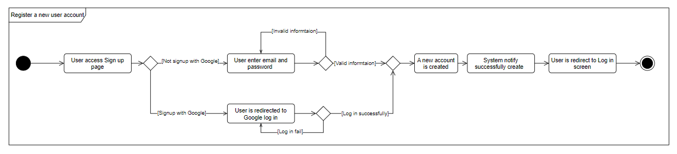

| UC ID and Name: | **UC-07_Register User Account** | | |
| --- | --- | --- | --- |
| Created By: | ChungLDD | Date Created: | 30/Sep/2024 |
| Primary Actor: | Guest | Secondary Actors: | None |
| Trigger: | The guest clicks “Sign up” on the page header, or he/she accesses an authenticated feature (from a link or type the page URL directly into the address bar) | | |
| Description: | A guest could register a new user account to perform further actions on the website. | | |
| Preconditions: | PRE-1. The guest could access the website. | | |
| Postconditions: | POST-1. A new account is created.  POST-2. The guest could use that new account to log in to the website. | | |
| Normal Flow | **07.0 Register a new account**  1. User accesses the Sign Up screen  2. User types in the registry details or choose other sign up option (see **12.1**)  3. User clicks the “Sign up” button.  4. System validates the registration information  5. Create an account in the database.  6. System notify that the account is created.  7. User is redirected to the Login screen to login by the new account. | | |
| Alternative Flows: | N/A | | |
| Exceptions: | **Message-E003: Not valid data**  The Error input user register  **Message-E010: Data already existed**  The input of user is already in the database | | |
| Priority: | Must Have | | |
| Frequency of Use: | MediuMedium | | |
| Business Rules: | BR4 | | |
| Other Information: |  | | |

### UC-08_View Website’s Information

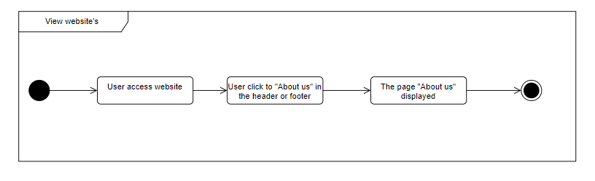

| UC ID and Name: | **UC-05_View Website’s Information** | | |
| --- | --- | --- | --- |
| Created By: |  | Date Created: | 30/Sep/2024 |
| Primary Actor: | Guest, Customer | Secondary Actors: | None |
| Trigger: | User clicks “About us” on the page footer. | | |
| Description: | The user could view all the information about the website. | | |
| Preconditions: | PRE-1. The user could access the website. | | |
| Postconditions: | POST-1. A page with all information about the website is displayed on the screen | | |
| Normal Flow | **05.0 View Website’s Information**  1. User navigates to the About Us page.  2. Information of the website is displayed, company’s name, owner, address, contact information, licenses… | | |
| Alternative Flows: | None | | |
| Exceptions: | None | | |
| Priority: | Must Have | | |
| Frequency of Use: | Medium | | |
| Business Rules: | None | | |
| Other Information: |  | | |
| Assumptions: |  | | |

### UC-09_View News List

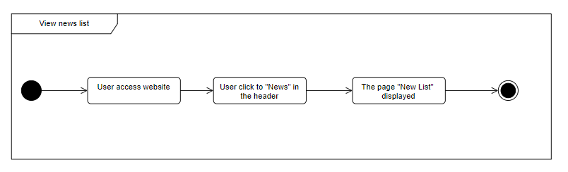

| UC ID and Name: | **UC-09_View News List** | | |
| --- | --- | --- | --- |
| Created By: | ChungLDD | Date Created: | 30/Sep/2024 |
| Primary Actor: | Guest, Customer | Secondary Actors: | None |
| Trigger: | User clicks “News” on the page header. | | |
| Description: | Users could view the list of news published on the website. | | |
| Preconditions: | PRE-1. The user could access the website. | | |
| Postconditions: | POST-1. A page with multiple news published pagination displayed. | | |
| Normal Flow | **09.0 View News List**  1. User navigates to the News List page.  2. List of news is displayed on the screen, with a thumbnail, title and brief information. | | |
| Alternative Flows: |  | | |
| Exceptions: |  | | |
| Priority: | Should Have | | |
| Frequency of Use: |  | | |
| Business Rules: | None | | |
| Other Information: |  | | |

### UC-10_View News’ Details

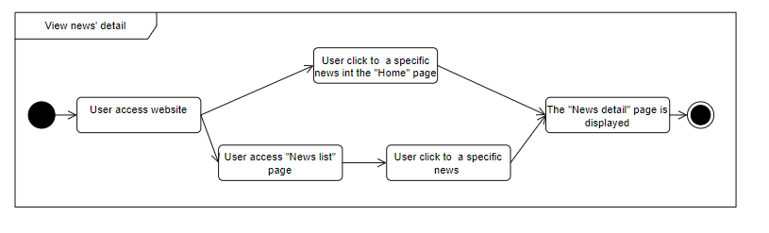

| UC ID and Name: | **UC-10_View News’s Details** | | |
| --- | --- | --- | --- |
| Created By: | ChungLDD | Date Created: | 30/Sep/2024 |
| Primary Actor: | Guest, Customer | Secondary Actors: | None |
| Trigger: | User clicks to a specific news in the Home Page or News List Page | | |
| Description: | Users could read more about a specific published news. | | |
| Preconditions: | PRE-1. The user could access the website. | | |
| Postconditions: | POST-1. The News Detail page is displayed on the screen.  POST-2. Users could access some related news from the page. | | |
| Normal Flow | **10.0 View News’s Details**  1. User navigates to the New Details page.  2. User scrolls up, down to read the news.  3. He/she could read related news with this news by clicking to the news in the sidebar | | |
| Alternative Flows: | None | | |
| Exceptions: | None | | |
| Priority: | Should Have | | |
| Frequency of Use: |  | | |
| Business Rules: | None | | |
| Other Information: |  | | |

### UC-11_Search news

#### 

| UC ID and Name: | **UC-11_Search news** | | |
| --- | --- | --- | --- |
| Created By: | ChungLDD | Date Created: | 30/Sep/2024 |
| Primary Actor: | Guest, Customer | Secondary Actors: | None |
| Trigger: | The user uses the search box on the header to search news. | | |
| Description: | Users could search for the news | | |
| Preconditions: | PRE-1. The user could access the website. | | |
| Postconditions: | POST-1. List of news is displayed on the screen | | |
| Normal Flow | **11.0 Search news**  1. User input keyword on the search box on the header and click button “Search”  2. The system retrieves data that satisfies the user's input conditions from the database  3. The user can view the list of news after searching | | |
| Alternative Flows: | None | | |
| Exceptions: | None | | |
| Priority: | Should Have | | |
| Frequency of Use: | Normal | | |
| Business Rules: | None | | |
| Other Information: |  | | |

### UC-12_View Auction List

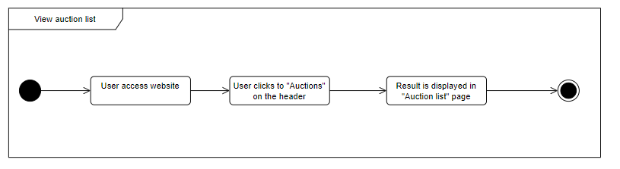

| UC ID and Name: | **UC-12_Auction List** | | |
| --- | --- | --- | --- |
| Created By: | TuNA | Date Created: | 01/10/2024 |
| Primary Actor: | Guest, Customer | Secondary Actors: | None |
| Trigger: | User clicks to “Đấu giá” then clicks “Danh sách đấu giá” or uses the search box on the header to search auctions. | | |
| Description: | Users could view the list of all auctions. | | |
| Preconditions: | PRE-1. The user could access the website. | | |
| Postconditions: | POST-1. On-going and scheduled auctions are displayed on the screen.  POST-2. Users could use a filter box to filter out the auction she/he wants.  POST-3. Users could navigate to a specific auction detail by clicking on it. | | |
| Normal Flow | **12.0 Auction List**  1. User navigates to the Auction List page.  2. Auctions are displayed paginated on the screen with information like auction’s name, images, short description, status and starting price. | | |
| Alternative Flows: | None | | |
| Exceptions: | None | | |
| Priority: | Should Have | | |
| Frequency of Use: |  | | |
| Business Rules: | None | | |
| Other Information: |  | | |
| Assumptions: |  | | |

### UC-13_View Auction’s Detail

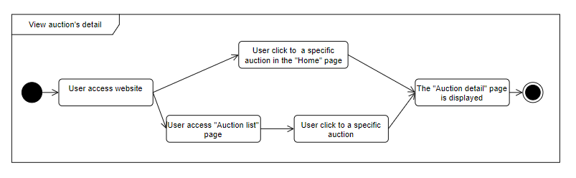

| UC ID and Name: | **UC-13_View Auction’s Detail** | | |
| --- | --- | --- | --- |
| Created By: | TuNA | Date Created: | 01/10/2024 |
| Primary Actor: | Guest, Customer | Secondary Actors: | None |
| Trigger: | User clicks to a specific auction on the home page or on the auction list. | | |
| Description: | Users could view an auction’s details. | | |
| Preconditions: | PRE-1. The user could access the website. | | |
| Postconditions: | POST-1. Information about the auction is displayed on the screen | | |
| Normal Flow | **13.0 View Auction’s Detail**  1. User navigates to the Auction Details page.  2. Information about the auction is displayed on the screen. | | |
| Alternative Flows: | None | | |
| Exceptions: | None | | |
| Priority: | Should Have | | |
| Frequency of Use: |  | | |
| Business Rules: | None | | |
| Other Information: |  | | |
| Assumptions: |  | | |

### UC-11_Search Auction (public)

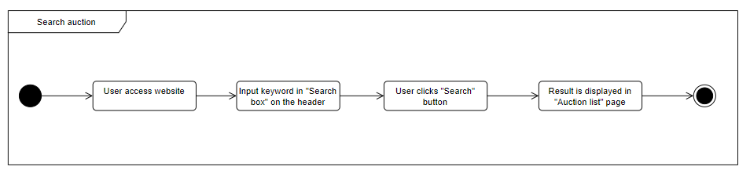

#### 

| UC ID and Name: | **UC-11_Search Auction** | | |
| --- | --- | --- | --- |
| Created By: | TuNA | Date Created: | 01/10/2024 |
| Primary Actor: | Guest, Customer | Secondary Actors: | None |
| Trigger: | The user uses the search box on the header to search auctions. | | |
| Description: | Users could search for the auction. | | |
| Preconditions: | PRE-1. The user could access the website. | | |
| Postconditions: | POST-1. List of search auction is displayed on the screen  POST-2. Users could read more information about an auction by clicking on an auction. | | |
| Normal Flow | **11.0 Search Auction**  1. User input keyword on the search box on the header and click button “Search”  2. Search results are displayed paginated on the screen with information like auction’s name, images, short description, status a starting price. | | |
| Alternative Flows: | None | | |
| Exceptions: | None | | |
| Priority: | Should Have | | |
| Frequency of Use: | Normal | | |
| Business Rules: | None | | |
| Other Information: |  | | |

## 3. Customer’s Functions

### UC-15_Register auction session

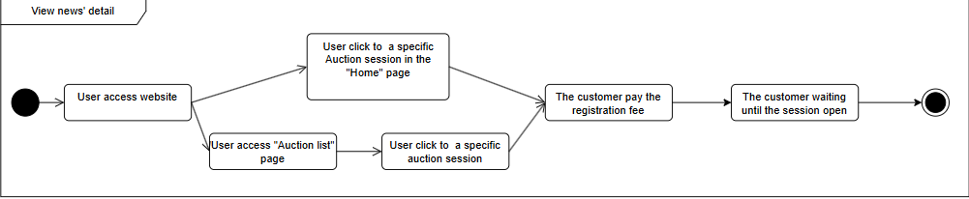

| UC ID and Name: | **UC-15_Register auction session** | | |
| --- | --- | --- | --- |
| Created By: | TuNA | Date Created: | 01/10/2024 |
| Primary Actor: | Customer | Secondary Actors: | None |
| Trigger: | User clicks to a specific auction session on HomePage or Auction List. | | |
| Description: | As a customer, I want to be able to access any auction I want. | | |
| Preconditions: | PRE-1. The customer must be logged into the system  PRE-2 The auction must be existed and hasn’t happened yet in the system  PRE-3 The account must be verified  PRE-4 The customer isn’t the seller of the land in this auction | | |
| Postconditions: | POST-1. The user's registration for the auction session is recorded in the system.  POST-2. The user receives a confirmation notification (via email or in-app message) about their successful registration.  POST-3. The payment status is updated as "Paid" upon successful payment processing.  POST-4. The registration details are stored in the user’s auction history for future reference. | | |
| Normal Flow | **15.0. Register Auction Session**  1. Customers click into the “Tham gia” button on the auction wanted in the Auction Detail page .  2. The system confirms the profile of the customer whether is verified.  3. The system deducts the participation fee from the user account.  4. The customer makes payment  5. The customer views actual auction meeting | | |
| Alternative Flows: | None | | |
| Exceptions: | **E014** - Auction has ended or been going on, users are not allowed to access. Auction has been goin on or ended | | |
| Priority: | Must Have | | |
| Frequency of Use: | Normal | | |
| Business Rules: | None | | |
| Other Information: | N/A | | |
| Assumptions: | N/A | | |

### UC-16_Join an auction session

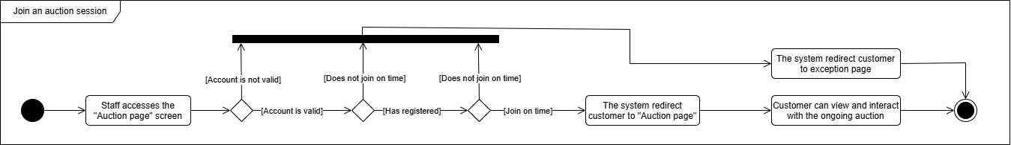

#### 

| UC ID and Name: | **UC-16_Join an auction session** | | |
| --- | --- | --- | --- |
| Created By: | TuNA | Date Created: | 01/10/2024 |
| Primary Actor: | Customer | Secondary Actors: | None |
| Trigger: | The customer clicks the “Xem trực tiếp” button on the “Auction detail” page, or from a link or type the page URL directly into the address bar | | |
| Description: | Register customer can join to auction session and view the detail information of ongoing auction | | |
| Preconditions: | PRE-1. The user has logged in.  PRE-2. The customer’s account is valid.  PRE-3. The customer has been register PRE-4. The customer has transferred register fee  PRE-5. The customer can only join the auction when the auction is ongoing | | |
| Postconditions: | POST-1. Customer can join the auction session successfully | | |
| Normal Flow | **37.0 Join an auction session**  1. Staff accesses the “Auction page” screen  2. The system checks if the customer’s account is valid or not (see **E012**)  3. If the account is valid, the system check if the customer has registered or not (see **E013**)  4. If the customer has registered, the system check if the customer has transferred the register fee or not (see **E013**)  5. If the customer has transferred the register fee, the system check if the moment the customer join the auction is when its ongoing (see **E014**)  6. If the joining moment is right, the system redirect customer to “Auction page”  7. Customer can view and interact with the ongoing auction | | |
| Alternative Flows: | None | | |
| Exceptions: | **E012 The customer’s account is not valid**  If the customer’s account is not valid, the system redirects the customer to the exception page  **E013 The customer has not registered**  If the customer has not registered, the system redirects the customer to the exception page  **E013 The customer has not transferred register fee**  If the customer has not transferred register fee, the system redirects the customer to the exception page  **E014 The joining moment is not on time**  If the joining moment is not on time, the system redirects the customer to the exception page | | |
| Priority: | Must Have | | |
| Frequency of Use: | High | | |
| Business Rules: | BR13, BR14 | | |
| Other Information: |  | | |
| Assumptions: |  | | |

### UC-17_Create Bid

#### 

| UC ID and Name: | **UC-17_Create Bid** | | |
| --- | --- | --- | --- |
| Created By: | TuNA | Date Created: | 01/10/2024 |
| Primary Actor: | Customer | Secondary Actors: | None |
| Trigger: |  | | |
| Description: | Customers place a bid in a real-time auction session using the auction page. | | |
| Preconditions: | PRE-1: Customer is logged in.  PRE-2: Customer has attended the auction.  PRE-3: A confirmation message is displayed to the staff. | | |
| Postconditions: | POST-1: The bid is successfully placed and displayed in the bidding history in real-time. | | |
| Normal Flow | **17.0 Create Bid**  1. Customer accesses the auction session page.  2. The auction page displays the current highest bid and the bid history.   3. Customer enters a bid amount and clicks "Đặt giá."   4. System verifies the bid amount and processes it.   5. The bid is added to the bidding history in real-time and becomes the current highest bid. | | |
| Alternative Flows: | None | | |
| Exceptions: | **E004** - The system cannot communicate with the server. The system will display an error message **E007** - Customer's bid is below the minimum increment. The system will display an error messagE **E006** - Auction session has ended. The system will display an error message | | |
| Priority: | Must Have | | |
| Frequency of Use: | High | | |
| Business Rules: | BR5, BR6 | | |
| Other Information: | The bidding process is conducted in real-time using WebSocket communication. | | |
| Assumptions: |  | | |

### UC-15_Register Asset Validation

#### 

| UC ID and Name: | **UC-15_Register Asset Validation** | | |
| --- | --- | --- | --- |
| Created By: | TungPV | Date Created: | 30/Sep/2024 |
| Primary Actor: | Customer | Secondary Actors: | None |
| Trigger: | The customer navigates to the Asset Registration page | | |
| Description: | The customer registers asset validation to auction. | | |
| Preconditions: | PRE-1. The customer is logged into the system. PRE-2. The Customer has a valid account. | | |
| Postconditions: | POST-1: The asset is successfully submitted and awaits validation by Staff. | | |
| Normal Flow | **15_Register Asset Validation**   1. The Customer navigates to the asset registration page. 2. The Customer fills out the asset details form with all required information. 3. The Customer uploads the necessary legal documents. 4. The Customer submits the registration fee through the payment gateway. 5. The system confirms the successful submission of the asset validation request. 6. The asset is set to "Pending Validation" status, waiting for Staff approval. | | |
| Alternative Flows: | None | | |
| Exceptions: | **E006** - The system cannot communicate with the payment gateway: An error message is displayed.  **E005** - Missing required legal documents: An error message is displayed prompting the Customer to upload all necessary documents.  **E003**- Invalid payment details: An error message is displayed when the payment fails. | | |
| Priority: | Must Have | | |
| Frequency of Use: | High | | |
| Business Rules: | BR7 | | |
| Other Information: |  | | |
| Assumptions: |  | | |

### 

### UC-38_View history registered assets list

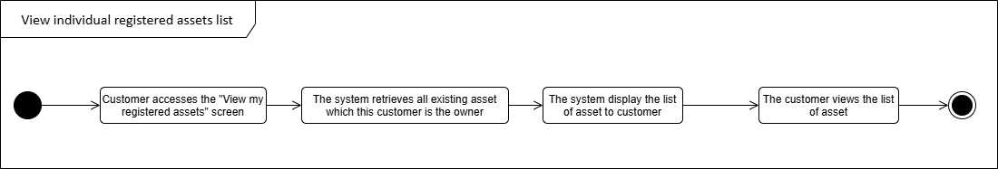

| UC ID and Name: | UC-38_View individual registered assets list | | |
| --- | --- | --- | --- |
| Created By: | TungPV | Date Created: | 01/October/2024 |
| Primary Actor: | Customer | Secondary Actors: | None |
| Trigger: | Customer clicks “View my registered assets” button in the sidebar, or from a link or type the page URL directly into the address bar | | |
| Description: | Customer can see all assets that he/she registered to the system | | |
| Preconditions: | PRE-1. The customer must be logged into the system | | |
| Postconditions: | POST-1. Customer sees all the assets that he/she registered to the system | | |
| Normal Flow | **38.0 View individual registered assets list**  1. Customer accesses the “View my registered assets” screen  2. The system retrieves all existing asset which has owner is that customer  3. The system displays the list of asset to the customer  4. The customer views the list of asset | | |
| Alternative Flows: | None | | |
| Exceptions: | None | | |
| Priority: | Must Have | | |
| Frequency of Use: | Normal | | |
| Business Rules: | None | | |
| Other Information: |  | | |
| Assumptions: |  | | |

### 

### UC-16_Withdraw Auction Asset Registration Request

#### 

| UC ID and Name: | **UC-16_ Withdraw Auction Asset Registration Request** | | |
| --- | --- | --- | --- |
| Created By: | TuNA | Date Created: | 30/Sep/2024 |
| Primary Actor: | Customer | Secondary Actors: | None |
| Trigger: | The customer navigates to the Auction Session History page | | |
| Description: | Allows the customer to withdraw Auction Asset Registration Request when it is in a withdrawable state. | | |
| Preconditions: | PRE-1. The customer is logged into the system.  PRE-2.The asset registration is in a withdrawable state. | | |
| Postconditions: | POST-1. The auction asset registration request is successfully canceled.  POST-2. The asset status is updated to indicate the cancellation. | | |
| Normal Flow | **16.0 Withdraw Auction Asset Registration Request**   1. The customer navigates to the auction asset registration page. 2. The system displays the list of assets registered by the customer. 3. The customer selects the asset they want to withdraw. 4. The system verifies that the selected asset is in a withdrawable state. 5. The customer confirms the withdraw 6. The system updates the asset status to " withdrawn" and confirms the action to the customer | | |
| Alternative Flows: | None | | |
| Exceptions: | **E009**: - If the asset is not in a withdrawable state, display the error message: "Asset registration cannot be canceled at this stage." | | |
| Priority: | Should Have | | |
| Frequency of Use: | Medium | | |
| Business Rules: |  | | |
| Other Information: |  | | |
| Assumptions: |  | | |

### UC-18_View Balance

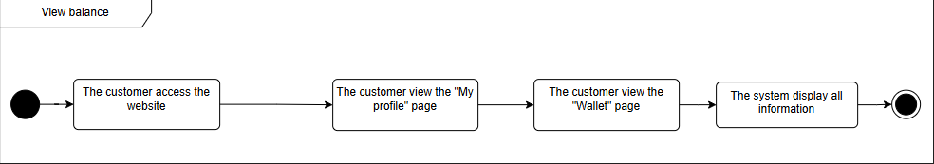

| UC ID and Name: | **UC-42_View balance** | | |
| --- | --- | --- | --- |
| Created By: | TungPV | Date Created: | 01/October/2024 |
| Primary Actor: | Customer | Secondary Actors: | None |
| Trigger: | The customer clicks the "View Wallet" button on the "My Profile" page or accesses the URL directly | | |
| Description: | As a customer, I want to be able to view how much money I have in the application so that I can analyze and make my own decision based on my finances. | | |
| Preconditions: | PRE-1. The customer must be logged into the system | | |
| Postconditions: | POST-1. The customer can view total money they have in the system. | | |
| Normal Flow | **42.0 View balance**   1. Customer accesses the “My profile” page 2. Customer accesses the “Wallet” page 3. The system retrieves the balance of this account 4. The system displays the balance to the customer 5. The customer views balance | | |
| Alternative Flows: | None | | |
| Exceptions: | None | | |
| Priority: | Must Have | | |
| Frequency of Use: | Normal | | |
| Business Rules: | None | | |
| Other Information: | N/A | | |
| Assumptions: | N/A | | |

### 

### UC-19_Deposite Payment (winner)

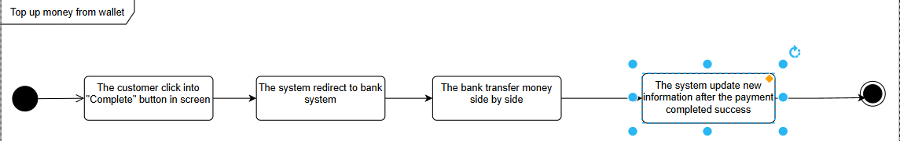

| UC ID and Name: | **UC-49_Deposite Payment** | | |
| --- | --- | --- | --- |
| Created By: | TungPV | Date Created: | 01/October/2024 |
| Primary Actor: | Customer | Secondary Actors: | None |
| Trigger: | User click to “Pay” button after win an auction. | | |
| Description: | As a customer, I want to be able pay my own winner deposit to make sure I have  I have asset. | | |
| Preconditions: | PRE-1. The customer must be logged into the system  PRE-2. The auction must be win the auction session | | |
| Postconditions: | POST-1. The user's registration for the auction session is recorded in the system.  POST-2. The user receives a confirmation notification (via email or in-app message) about their successful registration.  POST-3. The payment status is updated as "Paid" upon successful payment processing.  POST-4. The registration details are stored in the user’s auction history for future reference. | | |
| Normal Flow | **49.0 Deposite Payment**  1. The customer selects "Deposit Payment" on the website.  2.The system prompts the customer to enter the deposit amount and select a payment method.  3.The customer enters the deposit amount and confirms the payment.  4.The system system deduct money from wallet.  5.The system displays a success message to the customer, including the updated balance | | |
| Alternative Flows: | None | | |
| Exceptions: | None | | |
| Priority: | Must Have | | |
| Frequency of Use: | Normal | | |
| Business Rules: | None | | |
| Other Information: | N/A | | |
| Assumptions: | N/A | | |

### UC-20_Top up from Wallet

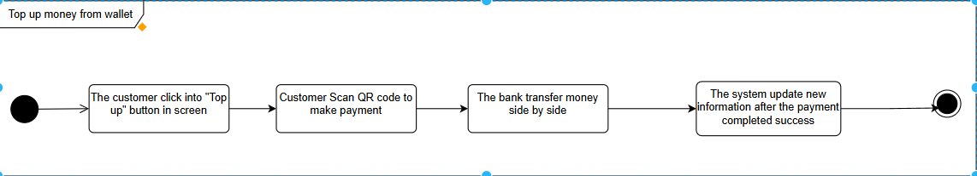

| UC ID and Name: | **UC-44 Top up from Wallet** | | |
| --- | --- | --- | --- |
| Created By: | TungPV | Date Created: | 01/October/2024 |
| Primary Actor: | Customer | Secondary Actors: | None |
| Trigger: | The customer clicks the "Withdraw" button on the "Wallet" page or accesses the URL directly | | |
| Description: | As a customer, I want to able to take the money I deposited or the profit from trading on the system for personal purposes. | | |
| Preconditions: | PRE-1. The customer must be logged into the system  PRE-2. The balance must greater or equal than 2000 VNG | | |
| Postconditions: | POST-1. User account balance has been updated  POST-2. Customer receive notification from the system | | |
| Normal Flow | **44.0 Top up from Wallet**  1. Customer click into “Withdraw” button in the “Wallet” page  2. The system checks if the auction exists [Exception 2a]  3. The system retrieves the balance of this account  4. The system displays the balance to the customer  5. The customer member views balance | | |
| Alternative Flows: | None | | |
| Exceptions: | N/A | | |
| Priority: | Must Have | | |
| Frequency of Use: | Normal | | |
| Business Rules: | N/A | | |
| Other Information: | N/A | | |
| Assumptions: | N/A | | |

### UC-66_Pay registration fee

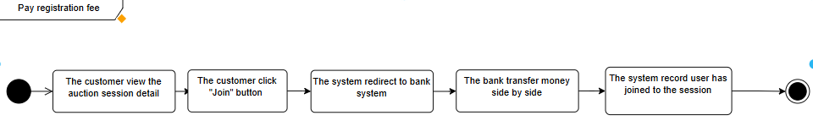

| UC ID and Name: | **UC-46_Pay registration fee** | | |
| --- | --- | --- | --- |
| Created By: | TungPV | Date Created: | 01/October/2024 |
| Primary Actor: | Customer | Secondary Actors: | None |
| Trigger: | User click to a specify auction session on HomePage or Auction List or Watch List | | |
| Description: | As a customer, I want to be able to access any auction I want. | | |
| Preconditions: | PRE-1. The customer must be logged into the system  PRE-2. The customer must be validated | | |
| Postconditions: | POST-1: The customer will be able to join the auction session.  POST-2: The auction record this user appear at the auction session. | | |
| Normal Flow | **46.0 Pay registration fee**  1. User view the auction detail  2. User click “Join” button to make request to the system.  3. The system has done the transaction through bank system.  4. Return user to auction session screen. | | |
| Alternative Flows: | None | | |
| Exceptions: | None | | |
| Priority: | Must Have | | |
| Frequency of Use: | Normal | | |
| Business Rules: | None | | |
| Other Information: | N/A | | |
| Assumptions: | N/A | | |

#### 

### UC-67_View payment history

#### 

| UC ID and Name: | **UC-67_View payment history** | | |
| --- | --- | --- | --- |
| Created By: | TungPV | Date Created: | 30/Sep/2024 |
| Primary Actor: | Customer | Secondary Actors: | None |
| Trigger: | User click into | | |
| Description: | Customer could see all transaction detail that they has done before | | |
| Preconditions: | PRE-1. The user has logged in.  PRE-2. The customer’s account is vali | | |
| Postconditions: | POST-1. Customer could see | | |
| Normal Flow | 1. Customer navigates to the payment history section. 2. System retrieves and displays all past transactions associated with the customer's account. 3. Customer reviews the transaction details. | | |
| Alternative Flows: | None | | |
| Exceptions: | None | | |
| Priority: | Must Have | | |
| Frequency of Use: | High | | |
| Business Rules: | BR13 | | |
| Other Information: |  | | |
| Assumptions: |  | | |

#### 

## 4. Customer care’s Functions

### UC-27_View news list

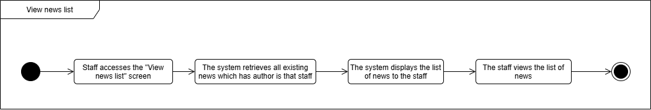

| UC ID and Name: | **UC-27_View news list** | | |
| --- | --- | --- | --- |
| Created By: | ChungLDD | Date Created: | 01/October/2024 |
| Primary Actor: | Customer care | Secondary Actors: | None |
| Trigger: | Customer care clicks “View news list” button in the sidebar, or from a link or type the page URL directly into the address bar | | |
| Description: | Staff can read all the news he/she has posted on system | | |
| Preconditions: | PRE-1. The Customer care must be logged into the system | | |
| Postconditions: | POST-1. Customer care sees all the news | | |
| Normal Flow | **27.0 View news list**  1. Customer care accesses the “View own news list” screen  2. The system retrieves all existing news which has author is that staff  3. The system displays the list of news to the staff  4. The Customer care views the list of news | | |
| Alternative Flows: | None | | |
| Exceptions: | None | | |
| Priority: | Must Have | | |
| Frequency of Use: | Normal | | |
| Business Rules: | None | | |
| Other Information: |  | | |

### 

### UC-28_View own news list



| UC ID and Name: | **UC-28_View own news list** | | |
| --- | --- | --- | --- |
| Created By: | ChungLDD | Date Created: | 01/October/2024 |
| Primary Actor: | Customer care | Secondary Actors: | None |
| Trigger: | Customer care clicks “View my own news list” button in the sidebar, or from a link or type the page URL directly into the address bar | | |
| Description: | Staff can read all the news he/she has posted on system | | |
| Preconditions: | PRE-1. The Customer care must be logged into the system | | |
| Postconditions: | POST-1. Customer care sees all the news which he/she is author | | |
| Normal Flow | **27.0 View own news list**  1. Customer care accesses the “View news list” screen  2. The system retrieves all existing news which has author is that staff  3. The system displays the list of news to the staff  4. The Customer care views the list of news | | |
| Alternative Flows: | None | | |
| Exceptions: | None | | |
| Priority: | Must Have | | |
| Frequency of Use: | Normal | | |
| Business Rules: | None | | |
| Other Information: |  | | |

### UC-29_View news detail

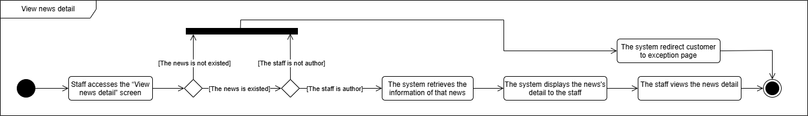

| UC ID and Name: | **UC-29_View news detail** | | |
| --- | --- | --- | --- |
| Created By: | ChungLDD | Date Created: | 01/October/2024 |
| Primary Actor: | Customer care | Secondary Actors: | None |
| Trigger: | Customer care clicks “View news detail” button in the "View news list" page, or from a link or type the page URL directly into the address bar | | |
| Description: | Customer care can be able to view the news detail which he/she is author, so that I can read that news | | |
| Preconditions: | PRE-1. The Customer care must be logged into the system  PRE-2. The news must exist in the system  PRE-3. The Customer care is author of that news | | |
| Postconditions: | POST-1. Staff sees the detail of news | | |
| Normal Flow | **29.0 View news detail**  1. Customer care accesses the “View news detail” screen  2. The system checks if the news exists  3. The system displays the news’s information to the staff  4. The Customer care views the detail of news | | |
| Alternative Flows: | None | | |
| Exceptions: | **Message-E001: The news does not exists** If the news does not exist, the system redirects the staff to the exception page | | |
| Priority: | Must Have | | |
| Frequency of Use: | Normal | | |
| Business Rules: |  | | |
| Other Information: |  | | |
| Assumptions: |  | | |

### 

## 5. Staff’s Functions

### 

### UC-30_Create news

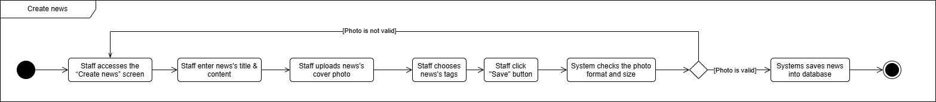

| UC ID and Name: | **UC-30_Create news** | | |
| --- | --- | --- | --- |
| Created By: | ChungLDD | Date Created: | 01/October/2024 |
| Primary Actor: | Customer care | Secondary Actors: | None |
| Trigger: | Customer care clicks “Create news” button in the sidebar, or from a link or type the page URL directly into the address bar | | |
| Description: | The staff be able to create news to the system | | |
| Preconditions: | PRE-1. The Customer care must be logged into the system | | |
| Postconditions: | POST-1. Customer care can create news successfully | | |
| Normal Flow | **30.0 Create news**  1. Customer care accesses the “Create news” screen  2. Customer care enters news’s title & content  3. Customer care uploads news’s cover photo  4. Customer care clicks “Save” button  5. System checks the photo format and size  6. If the cover photo is valid, system saves news into database | | |
| Alternative Flows: | None | | |
| Exceptions: | **Message-E003: The photo is not valid**  If the photo is not the correct format or size, the system reports that the photo was not suitable | | |
| Priority: | Must Have | | |
| Frequency of Use: | High | | |
| Business Rules: | BR2 | | |
| Other Information: |  | | |
| Assumptions: |  | | |

### UC-29_Update news (personal)

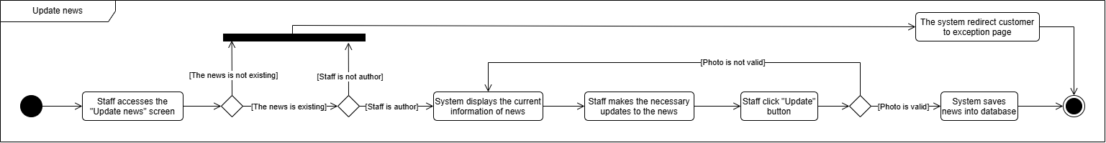

| UC ID and Name: | **UC-29_Update news** | | |
| --- | --- | --- | --- |
| Created By: | ChungLDD | Date Created: | 01/October/2024 |
| Primary Actor: | Staff | Secondary Actors: | None |
| Trigger: | Staff clicks “Update news” button in the "View news detail" page, or from a link or type the page URL directly into the address bar | | |
| Description: | The staff be able to update the news which he/she is author | | |
| Preconditions: | PRE-1. The staff must be logged into the system  PRE-2. The news must exist in the system  PRE-3. The staff must be the author of that news | | |
| Postconditions: | POST-1. Staff can edit the news successfully  POST-2. The news’s information is updated successfully in database | | |
| Normal Flow | **29.0 Update news**  1. Staff accesses the “Update news” screen  2. The system checks if the news exists (see **E001**)  3. If the news exists, the system checks if the staff is the author of the news (see **E013**)  4. If the staff is the author, the system displays the current information of the news for the staff to edit  5. The staff makes the necessary updates to the news information  6. The staff clicks the "Update" button  7. System checks the photo format and size (see **E003**)  8. If the cover photo is valid, system saves news into database | | |
| Alternative Flows: | None | | |
| Exceptions: | **E001 The news does not exist:**  3. If the news does not exist, the system redirects the staff to the exception page  4. The system terminates use case  **E013 The staff is not the news's author:**  4. If the staff is not the news’s author, the system redirects the staff to the exception page  5. The system terminates use case  **E003 The cover photo is not valid:**  8. If the photo is not the correct format or size, the system reports that the photo was not suitable  9. The system redirects the staff back to step 4 | | |
| Priority: | Must Have | | |
| Frequency of Use: | Low | | |
| Business Rules: | BR2 | | |
| Other Information: |  | | |
| Assumptions: |  | | |

### UC-30_Delete news (personal)

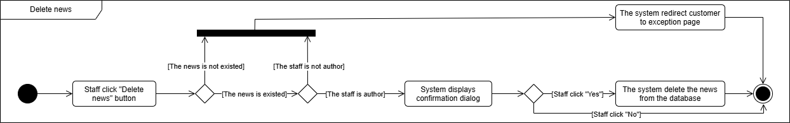

| UC ID and Name: | **UC-30_Delete news** | | |
| --- | --- | --- | --- |
| Created By: | ChienLDD | Date Created: | 01/October/2024 |
| Primary Actor: | Staff | Secondary Actors: | None |
| Trigger: | Staff clicks “Delete news” button in the "View news detail" page, or from a link or type the page URL directly into the address bar | | |
| Description: | The staff be able to delete news which he/she is author | | |
| Preconditions: | PRE-1. The staff must be logged into the system  PRE-2. The news must exist in the system  PRE-3. The staff must be the author of that news | | |
| Postconditions: | POST-1. Staff can delete the news successfully  POST-2. The news is deleted in database by the system | | |
| Normal Flow | **30.0 Delete news**  1. Staff clicks the “Delete news” button  2. The system checks if the news exists (see **E001**)  3. If the news exists, the system checks if the staff is the author of the news (see **E013**)  4. If the staff is the author, the system prompts the staff with a confirmation dialog: "Are you sure you want to delete this news?" (see **30.1**)  5. If the staff selects "Yes", the system deletes the news data from the database | | |
| Alternative Flows: | **30.1 The staff select “No” in dialog**  5. If the staff selects "No," the system terminates use case | | |
| Exceptions: | **E001 The news does not exist:**  3. If the news does not exist, the system redirects the staff to the exception page  4. The system terminates use case  **E013 The staff is not the news’s author:**  4. If the staff is not the news’s author, the system redirects the staff to the exception page  5. The system terminates use case | | |
| Priority: | Must Have | | |
| Frequency of Use: | Low | | |
| Business Rules: |  | | |
| Other Information: |  | | |
| Assumptions: |  | | |

### UC-31_View Validated Assets

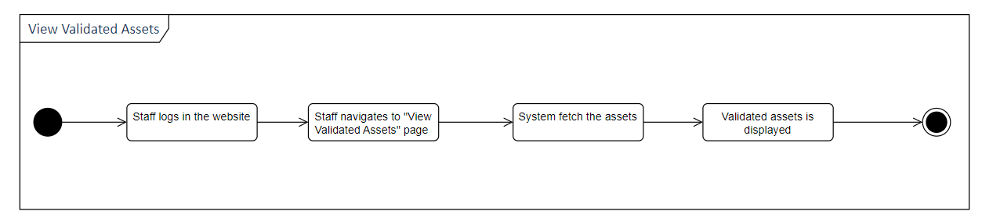

| UC ID and Name: | **UC-31_ View Validated Assets** | | |
| --- | --- | --- | --- |
| Created By: | TungPV | Date Created: | 30/Sep/2024 |
| Primary Actor: | Staff | Secondary Actors: | None |
| Trigger: | Staff accesses the page “Validated assets” from the navigation bar on the staff's dashboard. | | |
| Description: | Allows the staff to view the list of validated assets in the system. | | |
| Preconditions: | PRE-1. Staff is logged into the system. | | |
| Postconditions: | POST-1. The system displays the list of assets.  POST-2. Staff can access details of each asset for further processing. | | |
| Normal Flow | **31.0 View All Assets**   1. Staff navigates to the “Validated Assets” page. 2. The system retrieves pagination of validated Assets having in the database. 3. The system displays the list of retrieved assets. | | |
| Alternative Flows: | None | | |
| Exceptions: | **E001**: If data retrieval fails, display the error message: "Unable to retrieve validation requests. Please try again later." | | |
| Priority: | Must Have | | |
| Frequency of Use: | High | | |
| Business Rules: |  | | |
| Other Information: |  | | |
| Assumptions: |  | | |

### UC-33_View Waiting Validation Requests

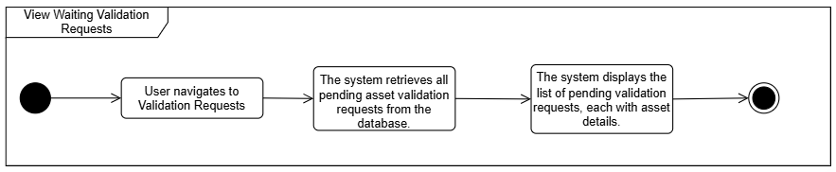

| UC ID and Name: | **UC-33_ View Waiting Validation Requests** | | |
| --- | --- | --- | --- |
| Created By: | TungPV | Date Created: | 30/Sep/2024 |
| Primary Actor: | Staff | Secondary Actors: | None |
| Trigger: | Staff accesses the validation request section in the system. | | |
| Description: | Allows the customer to view a list of assets that are waiting for validation. | | |
| Preconditions: | PRE-1. Staff is logged into the system.  PRE-2. There are pending asset validation requests in the system. | | |
| Postconditions: | POST-1. The system displays the list of pending asset validation requests.  POST-2. Staff can access details of each request for further processing. | | |
| Normal Flow | **33.0 View Waiting Validation Requests**   1. Staff navigates to the validation request page. 2. The system retrieves all pending validation requests. 3. The system displays the list of pending validation requests with asset details. | | |
| Alternative Flows: | None | | |
| Exceptions: | **E001**: If data retrieval fails, display the error message: "Unable to retrieve validation requests. Please try again later." | | |
| Priority: | Should Have | | |
| Frequency of Use: | Medium | | |
| Business Rules: |  | | |
| Other Information: |  | | |
| Assumptions: |  | | |

### UC-32_View Asset’s Details

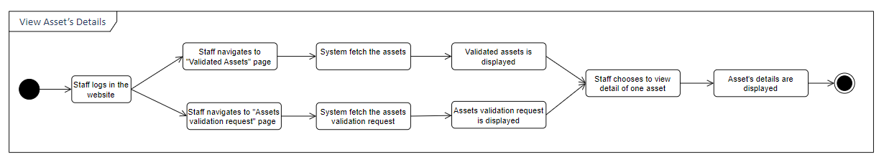

| UC ID and Name: | **UC-32_ View Asset’s Details** | | |
| --- | --- | --- | --- |
| Created By: | TungPV | Date Created: | 30/Sep/2024 |
| Primary Actor: | Staff | Secondary Actors: | None |
| Trigger: | Staff choose to see detail of a specific assets from the page “Validated Assets” or “Waiting Validation Request” page. | | |
| Description: | The staff could view details of the asset. | | |
| Preconditions: | PRE-1. Staff is logged into the system. | | |
| Postconditions: | POST-1. The system displays details of the asset.  POST-2. Staff can update the asset. | | |
| Normal Flow | **32.0 View Asset’s Details**   1. Staff navigates to the “Asset Detail” page. 2. The system retrieves details of the asset. 3. Details of the asset are displayed on the page. | | |
| Alternative Flows: | None | | |
| Exceptions: | **E001**: If data retrieval fails, display the error message: "Unable to retrieve validation requests. Please try again later." | | |
| Priority: | Must Have | | |
| Frequency of Use: | High | | |
| Business Rules: |  | | |
| Other Information: |  | | |
| Assumptions: |  | | |

### UC-35_Schedule auction

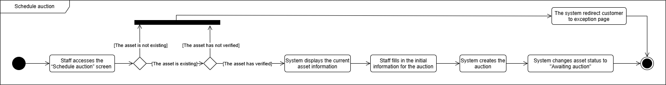

| UC ID and Name: | **UC-35_Schedule auction** | | |
| --- | --- | --- | --- |
| Created By: | TungPV | Date Created: | 01/October/2024 |
| Primary Actor: | Staff | Secondary Actors: | None |
| Trigger: | The staff member clicks the “Schedule auction” button in the “View assets awaiting scheduling” list, or from a link or type the page URL directly into the address bar | | |
| Description: | The staff be able to schedule auction according to a suitable timeline | | |
| Preconditions: | PRE-1. The staff must be logged into the system  PRE-2. The asset must exist in the system  PRE-3. The asset has been verified | | |
| Postconditions: | POST-1. Staff can schedule the auction successfully  POST-2. The system creates the auction session for that asset  POST-3. The system changes the asset’s status  POST-4. The system sets the start time for the auction session | | |
| Normal Flow | **35.0 Schedule auction**  1. Staff accesses the “Schedule auction” screen  2. The system checks if the asset exists (see **E001**)  3. If the asset exists, the system checks if the asset has been verified (see **E013**)  4. The system displays the asset information to the staff  5. The staff fills in the initial information for the auction  6. The system creates the auction  8. The system changes the status of the asset to "Awaiting auction" | | |
| Alternative Flows: | None | | |
| Exceptions: | **E001 The asset does not exist:**  3. If the asset does not exist, the system redirects the staff to the exception page  **E013 The asset has not been verified:**  4. If the asset has not been verified, the system redirects the staff to the exception page | | |
| Priority: | Must Have | | |
| Frequency of Use: | Low | | |
| Business Rules: |  | | |
| Other Information: |  | | |
| Assumptions: |  | | |

### UC-34_Validate Asset

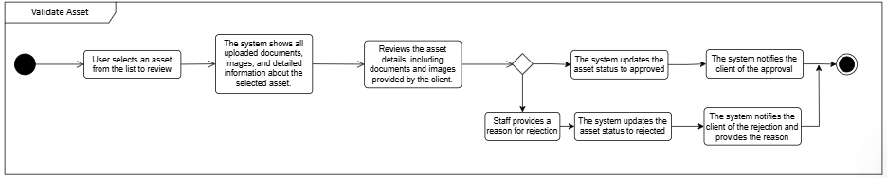

| UC ID and Name: | **UC-34_ Validate Asset** | | |
| --- | --- | --- | --- |
| Created By: | TungPV | Date Created: | 30/Sep/2024 |
| Primary Actor: | Staff | Secondary Actors: | None |
| Trigger: | Staff navigates to the Asset Waiting Validation page | | |
| Description: | Staff reviews and validates assets uploaded by clients for auction purposes. | | |
| Preconditions: | PRE-1. Staff is logged into the system.  PRE-2. The asset must be uploaded by a registered client.  PRE-3. The asset is in a pending validation state. | | |
| Postconditions: | POST-1. The asset is either marked as validated (approved) or rejected with reasons.  POST-2. The client is notified of the validation outcome. | | |
| Normal Flow | **34.0 Validate Asset**   1. The staff navigates to the asset validation section. 2. The system displays a list of assets awaiting validation. 3. The staff selects an asset to review. 4. The system displays all uploaded documents, images, and asset details. 5. The staff reviews the asset information and documentation. 6. The staff selects either "Approve" or "Reject" and provides reasons for rejection. 7. The system updates the asset's status based on the staff's decision. 8. The system notifies the client of the validation outcome. | | |
| Alternative Flows: | N/A | | |
| Exceptions: | **E004**: If an error occurs while retrieving the asset details, the system displays an error message: "Failed to retrieve asset details. Please try again later."  **E004**: If the validation process fails due to a system error, the staff is notified with the message: "Unable to validate asset at this moment. Please try again." | | |
| Priority: | Must Have | | |
| Frequency of Use: | High | | |
| Business Rules: | BR10 | | |
| Other Information: | N/A | | |
| Assumptions: | N/A | | |

### UC-40_Search asset

#### 

| UC ID and Name: | **UC-40_Search asset** | | |
| --- | --- | --- | --- |
| Created By: | TungPV | Date Created: | 30/Sep/2024 |
| Primary Actor: | Staff | Secondary Actors: | None |
| Trigger: | The staff uses the search box on the header to search assets. | | |
| Description: | Staff could search for the asset with specific input conditions | | |
| Preconditions: | PRE-1. Staff is logged into the system. | | |
| Postconditions: | POST-1. List of asset is displayed on the screen | | |
| Normal Flow | **40.0 Search asset**  1. Staff inputs keyword on the search box on the header and click button “Search”  2. The system retrieves data that satisfies the staff’s input conditions from the database  3. The staff can view the list of asset after searching | | |
| Alternative Flows: | None | | |
| Exceptions: | None | | |
| Priority: | Should Have | | |
| Frequency of Use: | Normal | | |
| Business Rules: | None | | |
| Other Information: |  | | |
| Assumptions: |  | | |

### UC-41_Search news

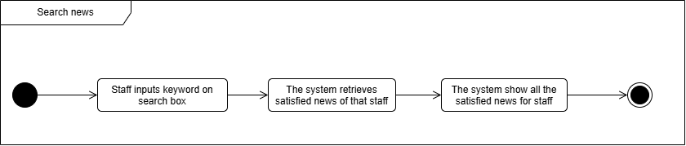

#### 

| UC ID and Name: | **UC-41_Search news** | | |
| --- | --- | --- | --- |
| Created By: | ChungLDD | Date Created: | 30/Sep/2024 |
| Primary Actor: | Staff | Secondary Actors: | None |
| Trigger: | The staff uses the search box on the header to search news. | | |
| Description: | Staff could search for the news with specific input conditions which he/she is author | | |
| Preconditions: | PRE-1. Staff is logged into the system. | | |
| Postconditions: | POST-1. List of news is displayed on the screen | | |
| Normal Flow | **41.0 Search news**  1. Staff inputs keyword on the search box on the header and click button “Search”  2. The system retrieves data that satisfies the staff’s input conditions and the staff is author of that news from the database  3. The staff can view the list of news after searching | | |
| Alternative Flows: | None | | |
| Exceptions: | None | | |
| Priority: | Should Have | | |
| Frequency of Use: | Normal | | |
| Business Rules: | None | | |
| Other Information: |  | | |
| Assumptions: |  | | |

### UC-42_Search auction

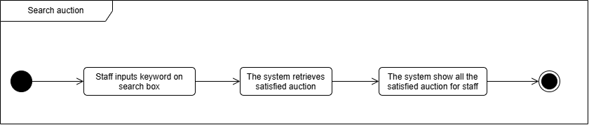

#### 

| UC ID and Name: | **UC-42_Search auction** | | |
| --- | --- | --- | --- |
| Created By: | ChienBM | Date Created: | 30/Sep/2024 |
| Primary Actor: | Staff | Secondary Actors: | None |
| Trigger: | The staff uses the search box on the header to search auctions. | | |
| Description: | Staff could search for the auction with specific input conditions | | |
| Preconditions: | PRE-1. Staff is logged into the system. | | |
| Postconditions: | POST-1. List of auctions is displayed on the screen | | |
| Normal Flow | **42.0 Search auction**  1. Staff input keyword on the search box on the header and click button “Search”  2. The system retrieves data that satisfies the staff’s input conditions from the database  3. The staff can view the list of auction after searching | | |
| Alternative Flows: | None | | |
| Exceptions: | None | | |
| Priority: | Should Have | | |
| Frequency of Use: | Normal | | |
| Business Rules: | None | | |
| Other Information: |  | | |
| Assumptions: |  | | |

#### 

### UC 68-View auction list

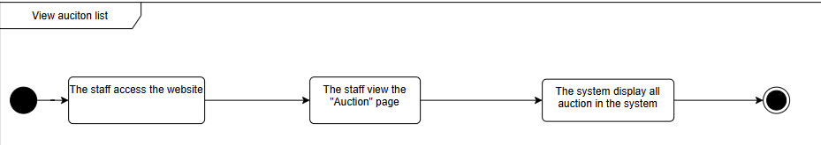

#### 

| UC ID and Name: | **UC-68_View Auction List** | | |
| --- | --- | --- | --- |
| Created By: | Staff | Date Created: | 30/Sep/2024 |
| Primary Actor: | Staff | Secondary Actors: | None |
| Trigger: | Staff clicks to “Auctions” or uses the search box on the header to search auctions. | | |
| Description: | Staff could view the list of auctions. | | |
| Preconditions: | PRE-1. The Staff could access the website. | | |
| Postconditions: | POST-1. On-going and scheduled auctions are displayed on the screen.  POST-2. Staff could use a filter box to filter out the auction she/he wants. POST-3. Staff could reorder the auctions using the “Sort by” function on the screen.  POST-4. Staff could navigate to a specific auction detail by clicking on it. | | |
| Normal Flow | **01.0 View Auction List**  1. Staff navigates to the Auction List page.  2. Auctions are displayed paginated on the screen with information like auction’s name, area and address of the land, auction’s schedule, status, starting price. | | |
| Alternative Flows: | None | | |
| Exceptions: | None | | |
| Priority: | Should Have | | |
| Frequency of Use: |  | | |
| Business Rules: | None | | |
| Other Information: |  | | |
| Assumptions: |  | | |

### UC-69_View auction’s detail

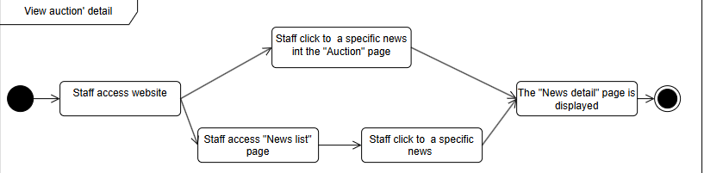

#### 

| UC ID and Name: | **UC-69_View Auction’s Detail** | | |
| --- | --- | --- | --- |
| Created By: | TungPV | Date Created: | 30/Sep/2024 |
| Primary Actor: | Staff | Secondary Actors: | None |
| Trigger: | Staffclicks to a specific auction on the home page or on the auction list. | | |
| Description: | Staffcould view an auction’s details. | | |
| Preconditions: | PRE-1. The Staffcould access the website. | | |
| Postconditions: | POST-1. Information about the auction is displayed on the screen | | |
| Normal Flow | **69.0 View Auction’s Detail**  1. Staffnavigates to the Auction Details page.  2. Information about the auction is displayed on the screen. | | |
| Alternative Flows: | None | | |
| Exceptions: | None | | |
| Priority: | Should Have | | |
| Frequency of Use: |  | | |
| Business Rules: | None | | |
| Other Information: |  | | |
| UC ID and Name: | **UC-02_View Auction’s Detail** | | |

## 6. Administrator’s Functions

### UC-24_Create Staff account

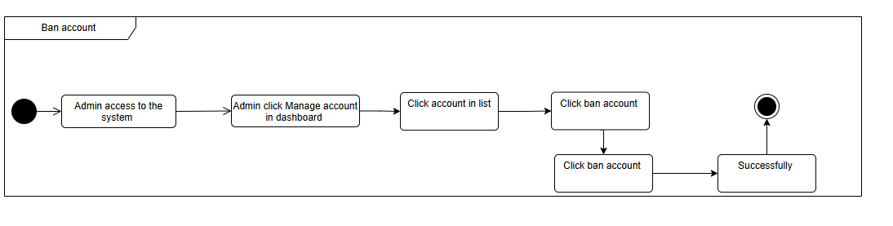

| UC ID and Name: | **UC-24_Create staff account** | | |
| --- | --- | --- | --- |
| Created By: | ChungLDD | Date Created: | 01/10/2024 |
| Primary Actor: | Admin | Secondary Actors: |  |
| Trigger: | Admin selects the Create Account option from the dashboard | | |
| Description: | Admin can create new staff account for new staff in the company to login system | | |
| Preconditions: | PRE-1: The Admin must be logged into the system. | | |
| Postconditions: | POST-1: The system displays Admin create new account staff successfully | | |
| Normal Flow: | **24.0 Create staff account**   1. Admin accesses the “Manage Account” screen. 2. Admin clicks the “Create New Account” button. 3. The system displays a form for entering account information. 4. Admin enters required information such as username, password, and other relevant details. 5. Admin clicks the “Save” button. 6. The system validates the entered information 7. The system checks if the username already exists in the database. 8. If the account information is valid and the username does not exist, the system saves the new account. 9. The system displays a confirmation message indicating that the account has been created successfully. | | |
| Alternative Flows: | None | | |
| Exceptions: | **E008-E003:**5a. If required fields are missing or invalid, the system displays an error message indicating which fields need correction.  **E001**:7a. If the username already exists, the system displays an error message prompting the Admin to choose a different username. | | |
| Priority: | High | | |
| Frequency of Use: | High | | |
| Business Rules: | N/A | | |
| Other Information: | N/A | | |
| Assumptions: | N/A | | |

### UC-23 _Ban Account

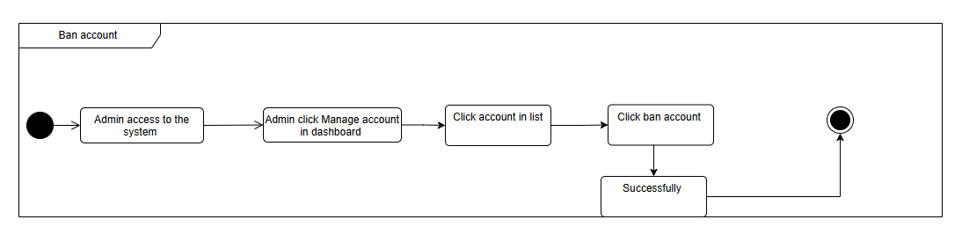

| UC ID and Name: | **UC-23_Ban Account** | | |
| --- | --- | --- | --- |
| Created By: | ChungLDD | Date Created: | 01/10/2024 |
| Primary Actor: | Admin | Secondary Actors: |  |
| Trigger: | Admin indicates to ban an user or staff | | |
| Description: | Admin can ban accounts user or staff who violates the term | | |
| Preconditions: | PRE-1: The Admin must be logged into the system.  PRE-2: The Admin choose user, staff want ban | | |
| Postconditions: | POST-1: When the normal flow completes successfully, the user who has been banned will not log in into the system. | | |
| Normal Flow: | **23.0 Ban Account**  1. Go to the Admin Page.  2. Click “Manage User” in the sidebar.  3. System displays a list of all users.  4. Admin chooses a user who wants to ban.  5. Admin clicks the “Ban” button.  6. The system shows pop-up confirmation. Choose “Yes”.  7. System changes “Ban” to “Unban”. | | |
| Alternative Flows: | N/A | | |
| Exceptions: | **E004:**6a. If the system fails to ban the user due to a server or database error, it displays an error message and prompts the Admin to try again later. | | |
| Priority: | High | | |
| Frequency of Use: | Low | | |
| Business Rules: | BR11 | | |
| Other Information: | N/A | | |
| Assumptions: | N/A | | |

### 

### UC-25_Validate account

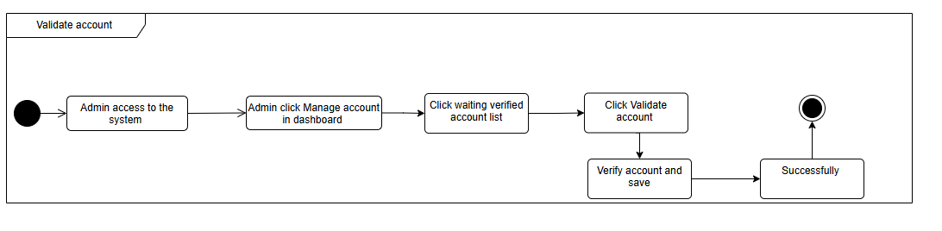

| UC ID and Name: | **UC-25_Validate account** | | |
| --- | --- | --- | --- |
| Created By: | ChungLDD | Date Created: | 01/10/2024 |
| Primary Actor: | Admin | Secondary Actors: |  |
| Trigger: | Admin select an account to validate from user’s manager dashboard | | |
| Description: | Admin validate user accounts to ensure they meet all requirements and are authorized for system access. | | |
| Preconditions: | PRE-1: The Admin must be logged into the system.  PRE-2: There must be user accounts pending validation. | | |
| Postconditions: | POST-1: The account status is updated to "approved" if validation is successful.  POST-2: The account is marked as "rejected" if validation fails or issues are found. | | |
| Normal Flow: | **25.0 Validate account**   1. The Admin accesses the "Manage Accounts" screen. 2. The system displays a list of all accounts pending validation. 3. The Admin selects an account to validate. 4. The system displays account details. 5. The Admin reviews the account details and clicks the "Validate" button. 6. The system updates the account status to "Approved." 7. The system notifies the Admin that the account has been validated successfully. | | |
| Alternative Flows: | N/A | | |
| Exceptions: | **E004**: If the system encounters a server or database error, it displays an error message and prompts the Admin to try again later. | | |
| Priority: | High | | |
| Frequency of Use: | Medium | | |
| Business Rules: | N/A | | |
| Other Information: | N/A | | |
| Assumptions: | N/A | | |

### 

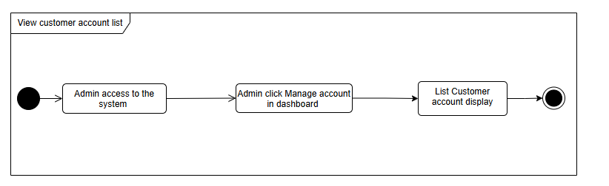

| UC ID and Name: | **UC-43_View customer’s account list** | | |
| --- | --- | --- | --- |
| Created By: | ChungLDD | Date Created: | 01/10/2024 |
| Primary Actor: | Admin | Secondary Actors: |  |
| Trigger: | Admin login the system and click manage account in navbar | | |
| Description: | Admin view list of customer account | | |
| Preconditions: | **PRE-1:** The Admin must be logged into the system.  **PRE-2:** There must be active customer accounts in the system database | | |
| Postconditions: | **POST-1:** The Admin successfully views the customer account list. | | |
| Normal Flow: | **43.0 View customer’s account list**   1. **Admin Login:** The Admin logs into the system and navigates to the "Manage Accounts" page. 2. **Display Customer Accounts:** The system displays a list of all customer accounts. | | |
| Alternative Flows: | N/A | | |
| Exceptions: | **E004**: If the system encounters a server or database error, it displays an error message and prompts the Admin to try again later. | | |
| Priority: | High | | |
| Frequency of Use: | Medium | | |
| Business Rules: | N/A | | |
| Other Information: | N/A | | |
| Assumptions: | N/A | | |

### UC-44_View account detail

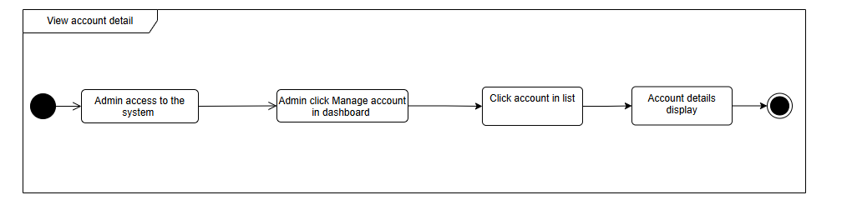

| UC ID and Name: | **UC-44_View account detail** | | |
| --- | --- | --- | --- |
| Created By: | ChungLDD | Date Created: | 01/10/2024 |
| Primary Actor: | Admin | Secondary Actors: |  |
| Trigger: | Admin select an account to validate from user’s manager dashboard | | |
| Description: | Enables the Admin to view a detail of customer accounts in the system. | | |
| Preconditions: | **PRE-1:** The Admin must be logged into the system.  **PRE-2:** There must be active customer accounts in the system database | | |
| Postconditions: | **POST-1:** The Admin successfully detail the customer account list. | | |
| Normal Flow: | **44.0 View customer’s account list**   1. **Admin Login:** The Admin logs into the system and navigates to the "Manage Accounts" page. 2. **Display Customer Accounts:** The system displays a list of all customer accounts. 3. **Select Account:** The Admin selects a specific customer account to view details. 4. **View Account Details:** The system presents detailed information for the selected account, including status, contact info, and registration date. | | |
| Alternative Flows: | N/A | | |
| Exceptions: | **E004**: If the system encounters a server or database error, it displays an error message and prompts the Admin to try again later. | | |
| Priority: | High | | |
| Frequency of Use: | Medium | | |
| Business Rules: | N/A | | |
| Other Information: | N/A | | |
| Assumptions: | N/A | | |

### UC-45_View waiting to verified account list

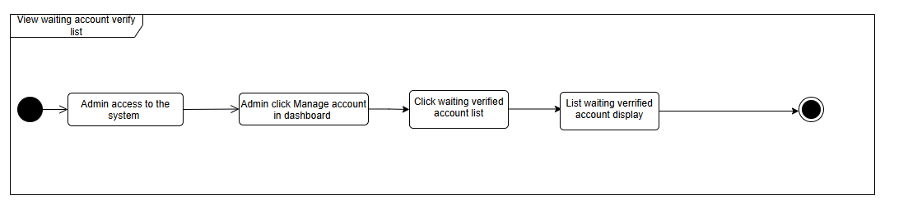

| UC ID and Name: | **UC-45_View waiting to verified account list** | | |
| --- | --- | --- | --- |
| Created By: | ChungLDD | Date Created: | 01/10/2024 |
| Primary Actor: | Admin | Secondary Actors: |  |
| Trigger: | The Admin logs into the system and clicks "Manage Account" in the navigation bar to view accounts awaiting verification and click filter | | |
| Description: | Enables the Admin to view a list of customer accounts that are pending verification and validation. | | |
| Preconditions: | **PRE-1:** The Admin must be logged into the system.  **PRE-2:** There must be customer accounts with a status of "pending verification." | | |
| Postconditions: | **POST-1:** The Admin successfully views the list of accounts awaiting verification. | | |
| Normal Flow: | **25.0 Validate account**   1. **Admin Login:** The Admin logs into the system and accesses the "Manage Accounts" page. 2. **Filter Pending Verification Accounts:** The system filters and displays only those customer accounts with a "Pending Verification" status. 3. **Select Account for Verification:** The Admin can click on an account to review its details and proceed with the verification process if necessary. | | |
| Alternative Flows: | N/A | | |
| Exceptions: | **E004**: If the system encounters a server or database error, it displays an error message and prompts the Admin to try again later. | | |
| Priority: | High | | |
| Frequency of Use: | Medium | | |
| Business Rules: | N/A | | |
| Other Information: | N/A | | |
| Assumptions: | N/A | | |

### 

### UC-46_Search account

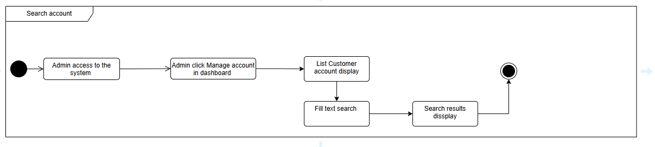

| UC ID and Name: |  | | |
| --- | --- | --- | --- |
| Created By: | ChungLDD | Date Created: | 01/10/2024 |
| Primary Actor: | Admin | Secondary Actors: |  |
| Trigger: | The Admin enters a search term in the account search bar on the "Manage Accounts" page. | | |
| Description: | Allows the Admin to search for specific customer accounts based on various criteria such as name, email, or account status. | | |
| Preconditions: | **PRE-1:** The Admin must be logged into the system.  **PRE-2:** Customer accounts must exist in the system's database. | | |
| Postconditions: | **POST-1:** The system displays search results that match the Admin's query.. | | |
| Normal Flow: | **46.0 Search account**   1. **Navigate to Manage Accounts:** The Admin logs into the system and goes to the "Manage Accounts" page. 2. **Enter Search:** The Admin enters a keyword (e.g., name, email, status) into the account search bar. 3. **Display Results:** The system retrieves and displays a list of accounts matching the search criteria.(**46.1**) 4. **Select Account:** The Admin can click on an account from the search results to view further details or perform actions, such as validation or deactivation. | | |
| Alternative Flows: | **46.1:** The system displays a message indicating that no accounts match the search query and suggests refining the search. | | |
| Exceptions: | **E001**: Not exist or not found | | |
| Priority: | High | | |
| Frequency of Use: | Medium | | |
| Business Rules: | N/A | | |
| Other Information: | N/A | | |
| Assumptions: | N/A | | |

### UC-47_View staff’s account list

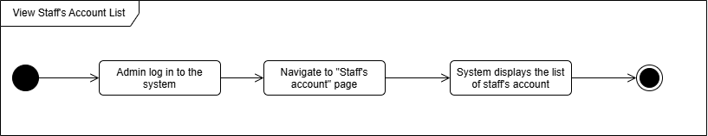

| UC ID and Name: | **UC-_View staff’s account list** | | |
| --- | --- | --- | --- |
| Created By: | DieuTTH | Date Created: | 01/10/2024 |
| Primary Actor: | Admin | Secondary Actors: |  |
| Trigger: | Admin login the system and click manage account in navbar | | |
| Description: | Admin could view list of staff’s account | | |
| Preconditions: | **PRE-1:** The Admin must be logged into the system.  **PRE-2:** There must be staff’s accounts in the system database | | |
| Postconditions: | **POST-1:** The Admin successfully views the customer account list. | | |
| Normal Flow: | **47.0 View customer’s account list**   1. The Admin logs into the system 2. He/she navigates to the “ Staff’s Accounts" page. 3. The system displays a list of staff’s accounts. (See **47.0 E1**) | | |
| Alternative Flows: | N/A | | |
| Exceptions: | **47.0 E1 the system encounters a server or database error**   1. Displays an error message **E004** and prompts the Admin to try again later. | | |
| Priority: | High | | |
| Frequency of Use: | Medium | | |
| Business Rules: | N/A | | |
| Other Information: | N/A | | |
| Assumptions: | N/A | | |

# III. Design Specifications

## 1. Public screen

### 1.1 Sign in

#### UI Design

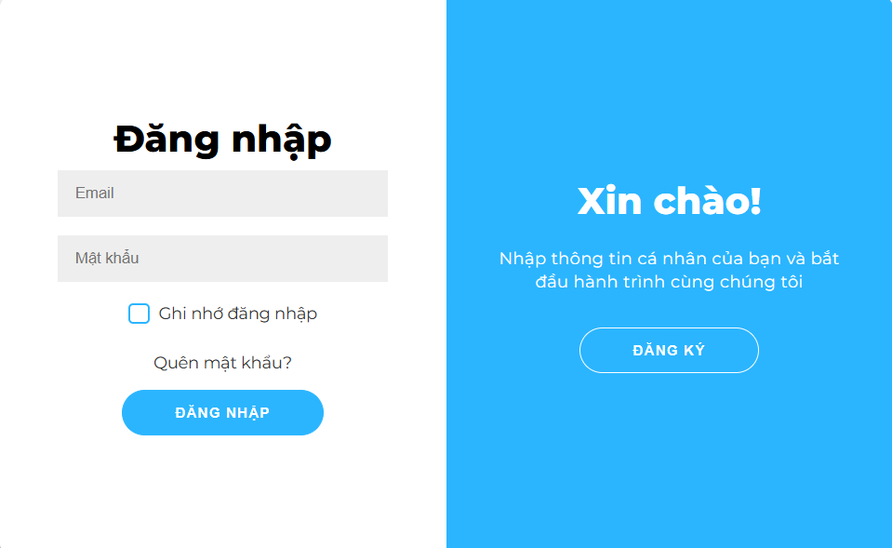

| **Field Name** | **Field Type** | **Description** |
| --- | --- | --- |
| Email | Text box | User inputs their valid email address for login. |
| Password | Password box | User inputs their account password. |
| Login | Button | Button to submit the login request with email and password. |
| Forgot Password? | Hyperlink | Link to navigate to the password recovery page. |
| Register | Button | Button to navigate to the registration page for new users. |

#### Database Access

##### 

| **Table** | **CRUD** | **Description** |
| --- | --- | --- |
| User | RU | Check if the user information exists in the system. |
| Password | RU | Validate the user’s password for the corresponding account. |

#### SQL Commands

1/ Query to authenticate user for login:

SELECT user_id, email, password_hash

FROM users

WHERE email = ?

AND password_hash = ?

2/ Query to retrieve email for password recovery:

SELECT email

FROM users

WHERE email = ?

### 1.2 Sign up

#### UI Design

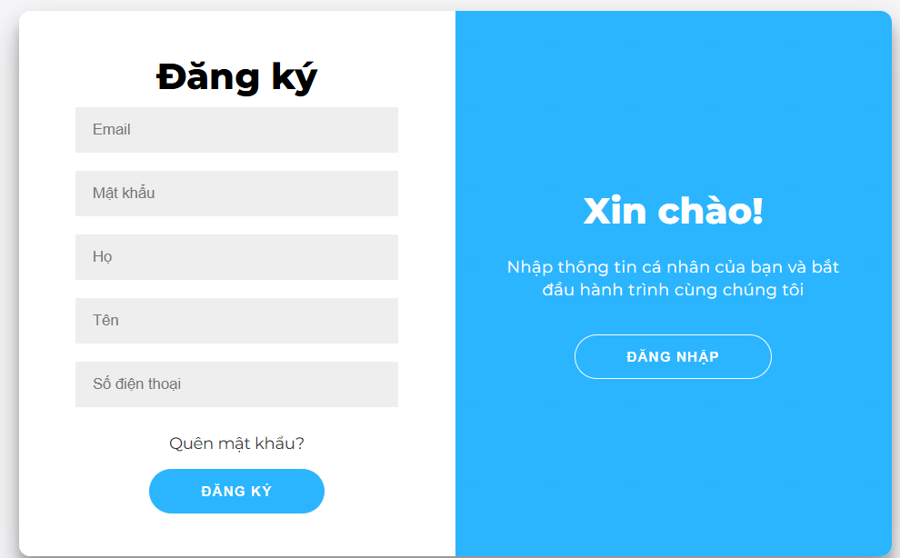

| **Field Name** | **Field Type** | **Description** |
| --- | --- | --- |
| Username | Text Box | User inputs their chosen username for the account |
| Email | Text box | User inputs their valid email address for login. |
| Password | Password box | User inputs their account password. |
| First name | Text box | User inputs their First name. |
| Last name | Text box | User inputs their Last name. |
| Phone | Number | User inputs their account phone number. |
| Register | Button | Button to submit the registration form with all details. |
| Login | Button | Button to navigate to the login page. |

#### Database Access

| **Table** | **CRUD** | **Description** |
| --- | --- | --- |
| User | C | Inserts the new user's information (username, email, password) into the database. |
| Email | R | Checks if the email is already in use to avoid duplicate registrations. |

#### SQL Commands

1/ Insert the new user data into the database upon registration:

INSERT INTO users (username, email, password_hash, first_name, last_name_phone)

VALUES (?, ?, ?,?,?)

2/ Query to check if the email is already registered:

SELECT email

FROM users

WHERE email = ?

3/ Query to check if the phone is already registered:

SELECT phone

FROM users

WHERE phone= ?

### 1.3 Forget Password

#### UI Design

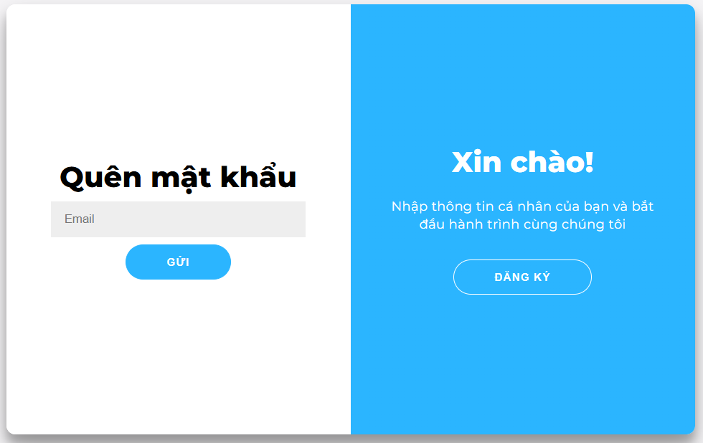

| **Field Name** | **Field Type** | **Description** |
| --- | --- | --- |
| Email | Text Box | User inputs their registered email address for password recovery. |
| OK | Button | Button to submit the email for password recovery. |

#### Database Access

| **Table** | **CRUD** | **Description** |
| --- | --- | --- |
| User | C | Inserts the new user's information (username, email, password) into the database. |
| Email | R | Checks if the email is already in use to avoid duplicate registrations. |

#### SQL Commands

1/ Query to check if the email exists for password recovery:

SELECT email

FROM users

WHERE email = ?

2/ Insert a password reset token:

INSERT INTO password_reset (email, token, expiry_time)

VALUES (?, ?, ?)

### 1.4 Homepage

#### UI Design

#### 

| **Field Name** | **Field Type** | **Description** |
| --- | --- | --- |
| Search box | Text Box | User inputs the keyword to search for auctions. |
| Search button | Button | Button to trigger the search function on the header. |
| Auction card | | |
| Auction time | Text | The time of the auction session |
| Cover image | Image | The image represents the asset auctioned. |
| Asset’s name | Text | The name of the asset auctioned. |
| Starting time | Text | The starting price of the auction session. |
| News card | | |
| News thumbnail | Image | The thumbnail of the news |
| News’ name | Text | The name of the news. |
| News’ brief infor | Text | A preview of the news. |

#### Database Access

| **Table** | **CRUD** | **Description** |
| --- | --- | --- |
| Auction | R | Get the upcoming and successful auctions session. |
| News | R | Get the latest news. |

#### SQL commands

1. Get the auctions session

SELECT top 6 from Auction_session

order by DESC

1. Get the latest news

SELECT * FROM News WHERE create_at DESC;

### 1.5 Website Information

### 1.6 New list

#### UI Design

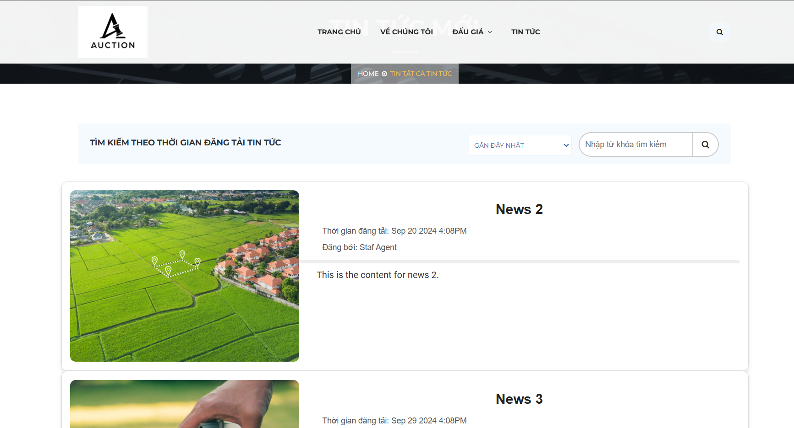

| **Field Name** | **Field Type** | **Description** |
| --- | --- | --- |
| Search Bar | Text Box | User inputs keywords to search for specific news articles. |
| Search Button | Button | Button to trigger the search functionality. |
| News Items | List | Displays a list of news articles, each showing a thumbnail, date, title, and description. |
| New Articles Section | Section | Displays the latest news articles in a smaller format. |

#### Database Access

| **Table** | **CRUD** | **Description** |
| --- | --- | --- |
| News | R | Queries the list of news articles from the database. |

#### SQL Commands

1/ Query to retrieve news articles:

SELECT news_id, title, content, created_date, image_url

FROM news

WHERE title LIKE ? OR content LIKE ?

ORDER BY created_date DESC

2/ Query to retrieve the latest news:

SELECT news_id, title, created_date, image_url

FROM news

ORDER BY created_date DESC

### 1.7 News detail

#### UI Design

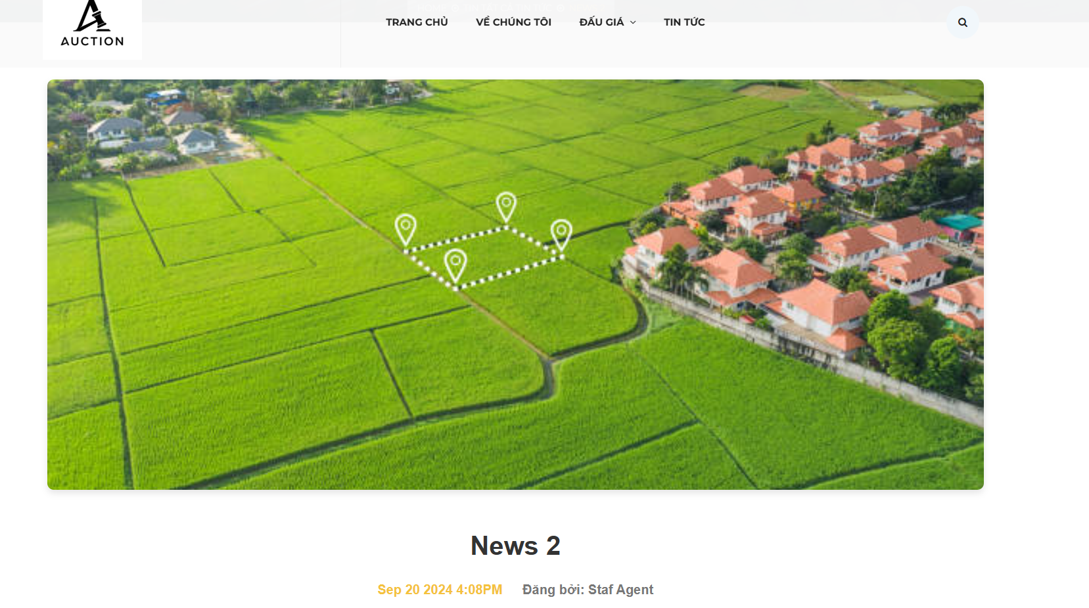

| **Field Name** | **Field Type** | **Description** |
| --- | --- | --- |
| News Title | Label | Displays the title of the news article. |
| News Content | Text | Displays the content of the news article. |
| Image | Image | Displays the main image associated with the news article. |
| Search Bar | Text Box | Allows users to input keywords to search for news articles. |
| Search Button | Button | Button to trigger the search functionality. |
| Recent Posts | Section | Displays a list of recent news articles. |

#### Database Access

| **Table** | **CRUD** | **Description** |
| --- | --- | --- |
| News | R | Retrieves the news article details including title, content, and image. |

#### SQL Commands

1/ Retrieve the specific news article details:

SELECT news_id, title, content, image_url

FROM news

WHERE news_id = ?;

2/ Search for news articles by keyword:

SELECT news_id, title, content, created_date

FROM news

WHERE title LIKE ? OR content LIKE ?

ORDER BY created_date DESC;

### 1.9 View asset list

#### UI Design

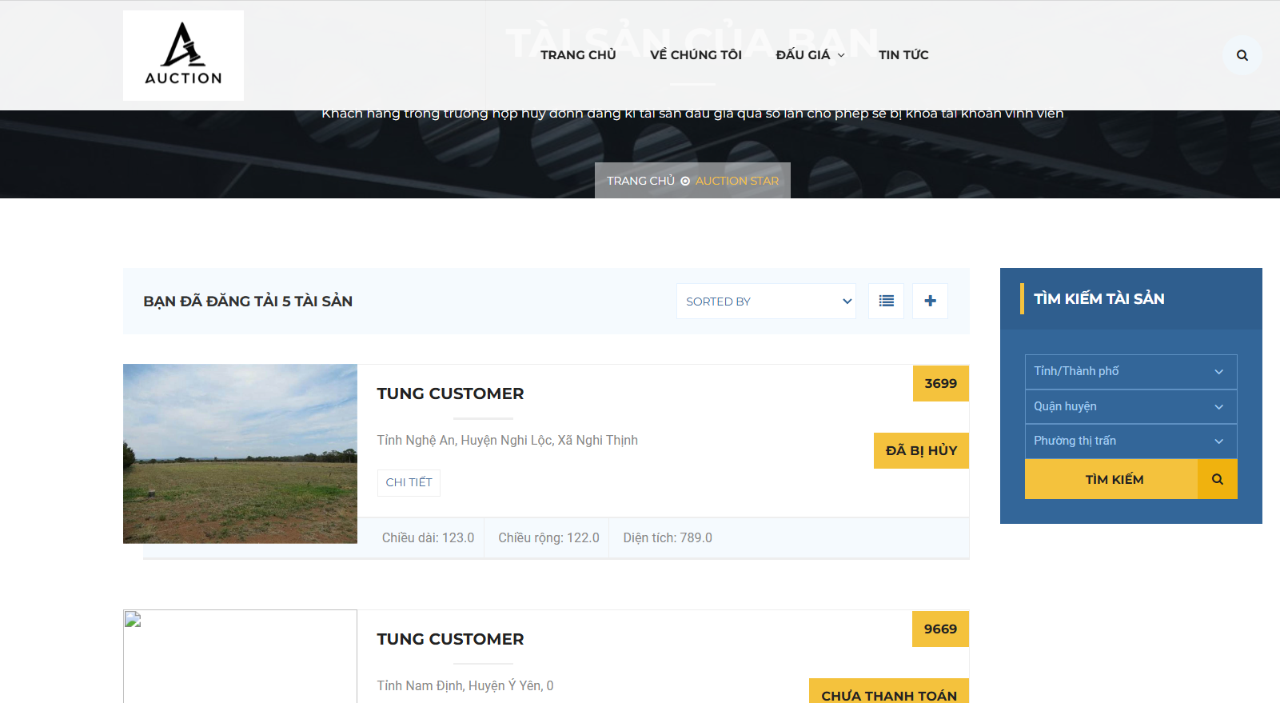

| **Field Name** | **Field Type** | **Description** |
| --- | --- | --- |
| ***Search Fields*** | | |
| Search Type | Select | User choose the news asset they want |
| Search Phase | Text | User enter the news’s asset to search |
| Detail | Button | Get detail asset they want |
| View in map | Button | Get location asset in map |
| ***Assets*** | | |
| Title | Text | Asset title |
| Cover photo | Image | Asset cover photo |

#### Database asset

#### 

| **Table** | **CRUD** | **Description** |
| --- | --- | --- |
| Asset | R | Get all asset that satisfy the search constraint from Asset table |

#### SQL Commands

1/ Get all asset that satisfy the search constraint from Asset table

SELECT * FROM Asset WHERE title LIKE CONCAT('%', ?, '%') OR id = ? OR price BETWEEN ? AND ? OR status = ?

### 1.10 View auction list

#### UI Design

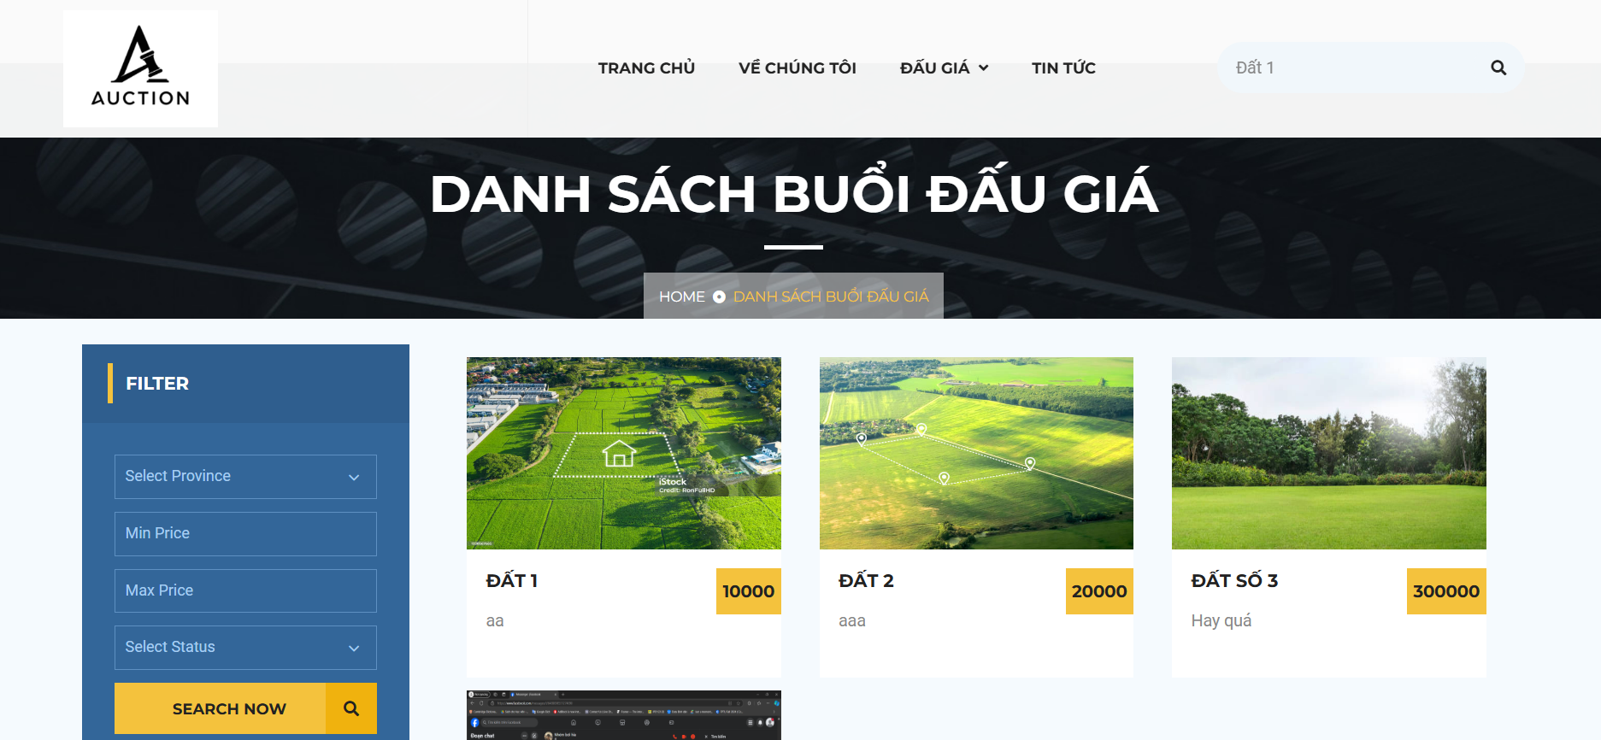

| **Field Name** | **Field Type** | **Description** |
| --- | --- | --- |
| ***Search Fields*** | | |
| Search criteria | Text | Search the auction with name contains criterias |
| ***Filter Fields*** | | |
| Province Select | Select | User choose the province of land they want |
| Max Price | Text | User enter the maximum price they want |
| Min Price | Text | User enter the minimum price they want |
| Status Select | Select | User choose the status of auction they want |
| Search Now Button | Button | Search the auction with the criterias above |
| ***Auction*** | | |
| Title | Button | LandName and link to auction detail |
| Cover photo | Image | Asset cover photo |

#### Database asset

#### 

| **Table** | **CRUD** | **Description** |
| --- | --- | --- |
| Auction | R | Get all auction that satisfy the search constraint from Asset table |

#### SQL Commands

1/ Get all auction that satisfy the search constraint from Auction table

SELECT a.*

FROM Auction a

JOIN Land s ON a.land_id = s.id

WHERE s.title LIKE CONCAT('%', ?, '%')

OR a.id = ?

OR a.price BETWEEN ? AND ?

OR a.status = ?

### 

### 1.11 View auction detail

#### UI Design

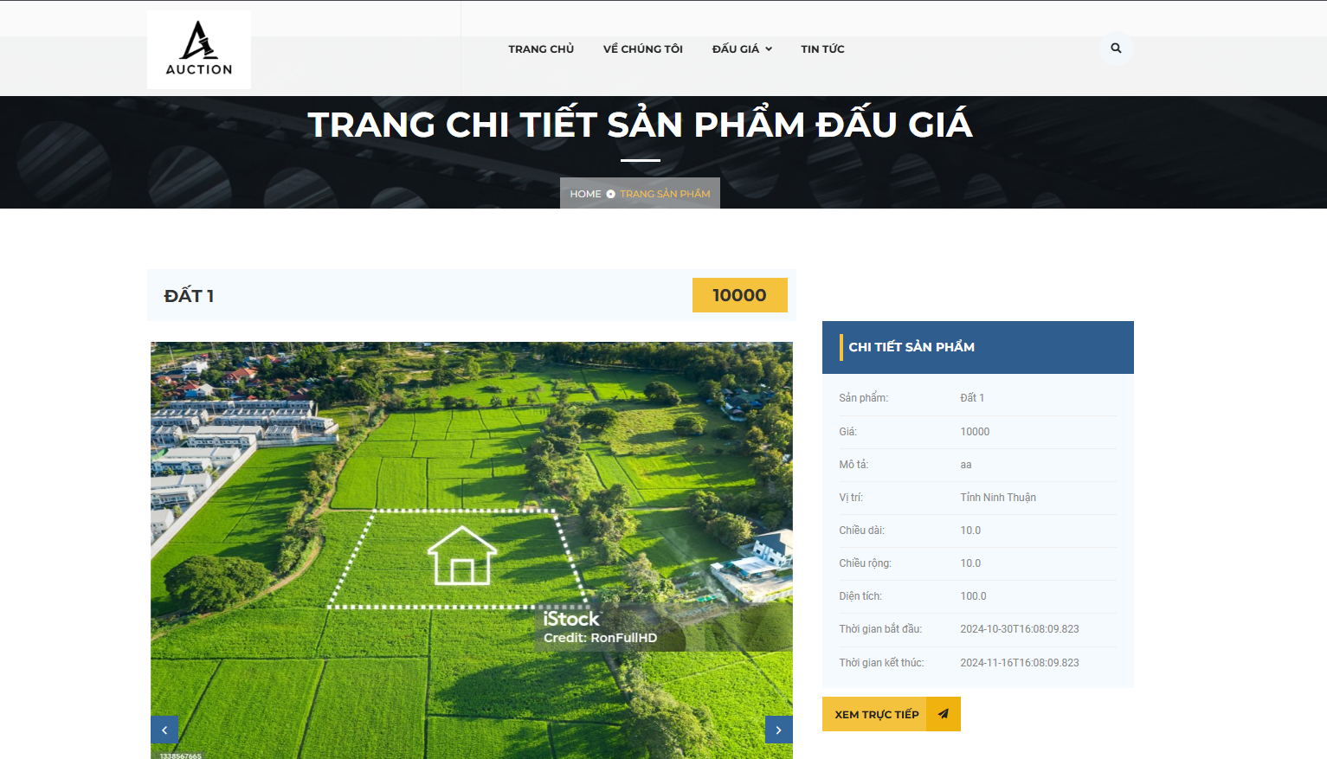

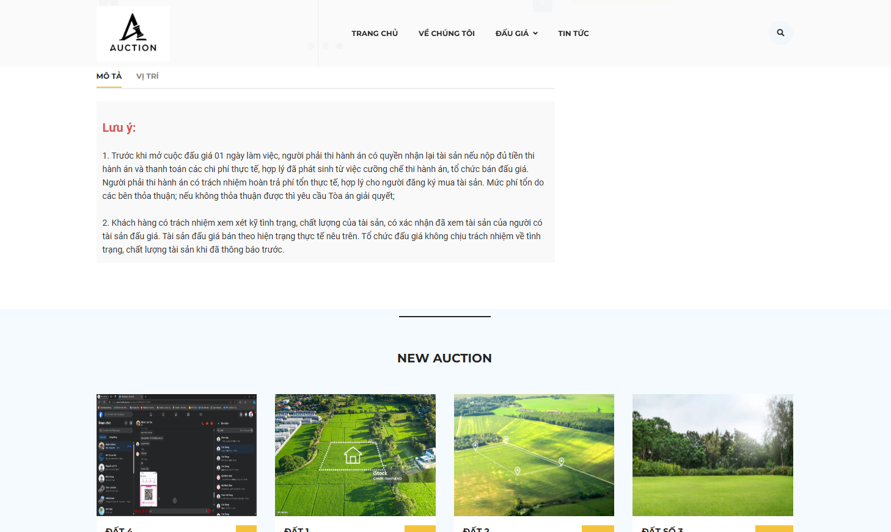

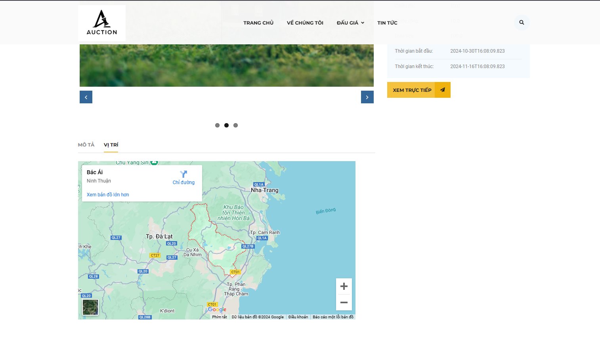

| **Field Name** | **Field Type** | **Description** |
| --- | --- | --- |
| ***Auctions*** | | |
| Title | Text | Asset title |
| Cover photo | Image | Asset cover photo |
| Time | Date time | Auction time start and finish |

#### Database asset

#### 

| **Table** | **CRUD** | **Description** |
| --- | --- | --- |
| Auction | R | Get auction that satisfy the search constraint from auction table |

#### SQL Commands

1/ Get all auction that satisfy the search constraint from Auction table

SELECT s.title, a.starttime, a.endtime, s.image

FROM Auction a

JOIN Asset s ON a.asset_id = s.id

WHERE a.id = ?

### 1.12 View asset detail

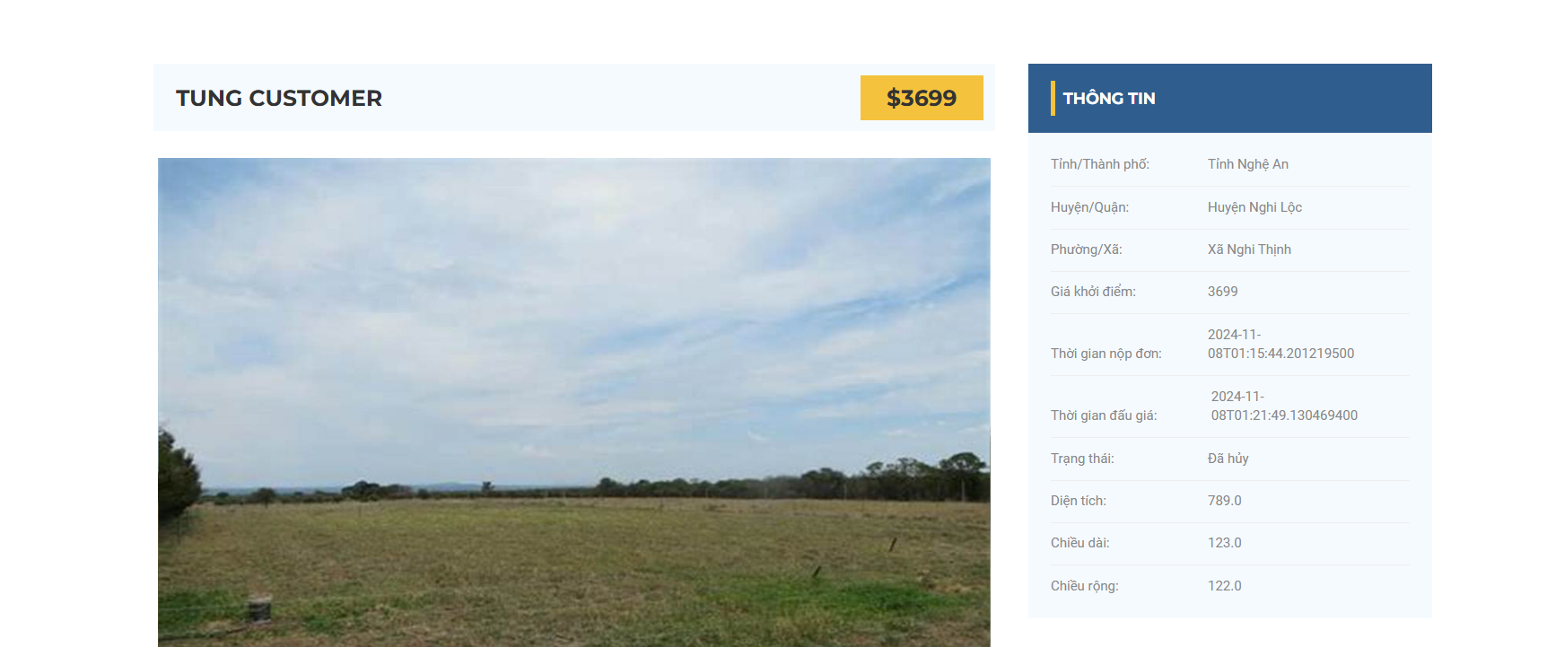

#### UI Design

| **Field Name** | **Field Type** | **Description** |
| --- | --- | --- |
| ***Search Fields*** | | |
| Registration | Button | User register to join auction |
| ***Assets*** | | |
| Title | Text | Asset title |
| Cover photo | Image | Asset cover photo |

#### Database asset

#### 

| **Table** | **CRUD** | **Description** |
| --- | --- | --- |
| Asset | R | Get Asset that satisfy the search constraint from Asset table |

#### SQL Commands

1/ Get all Asset that satisfy the search constraint from Asset table

SELECT s.title, a.starttime, a.endtime, s.image

FROM Auction a

JOIN Asset s ON a.asset_id = s.id

WHERE a.id = ?

### 1.13 Register Auction Session

#### UI Design

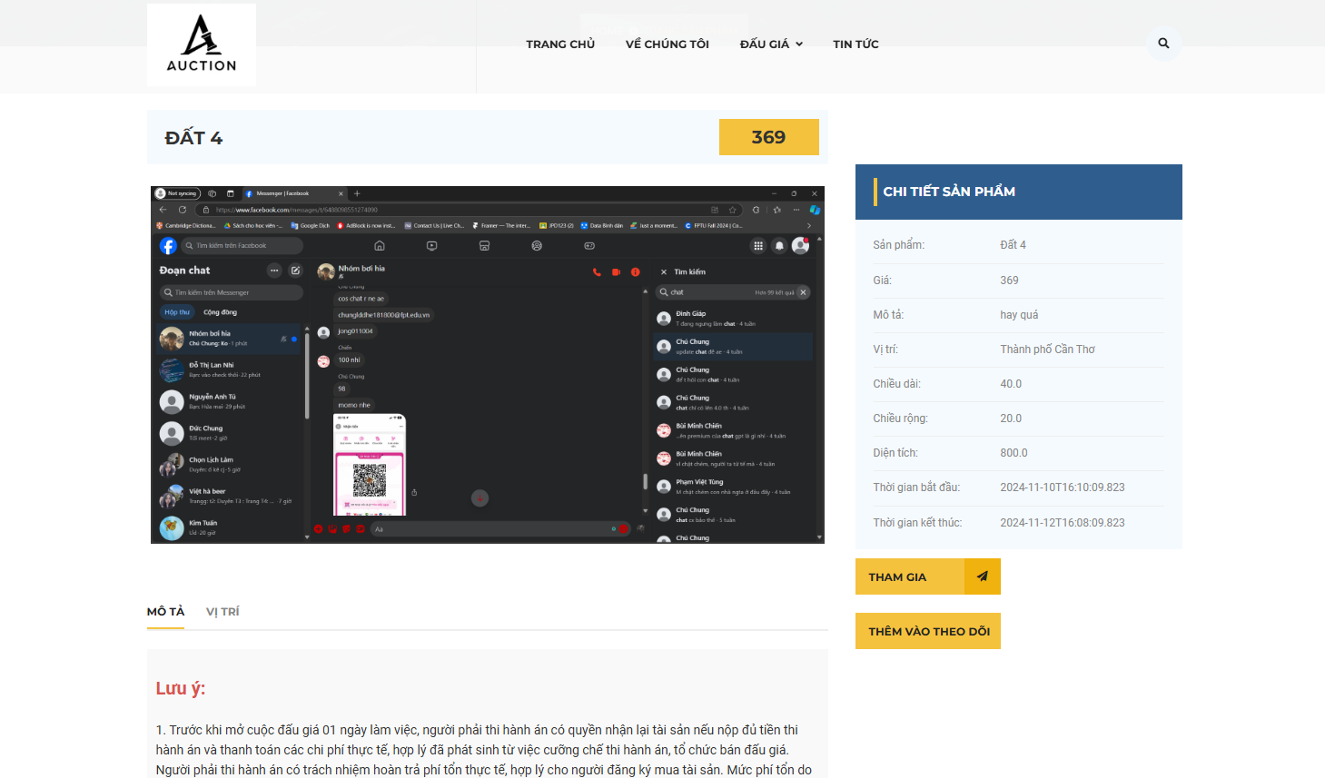

| **Field Name** | **Field Type** | **Description** |
| --- | --- | --- |
| ***Search Fields*** | | |
| Registration | Button | User register to join auction |
| ***Assets*** | | |
| Title | Text | Asset title |
| Document | Image | Auction Law |

#### Database asset

#### 

| **Table** | **CRUD** | **Description** |
| --- | --- | --- |
| Auction | C, R | Register for auction participation |

#### SQL Commands

1/ Get all Auction that satisfy the search constraint from Auction table

SELECT s.title, s.document, s.description

FROM Auction a

JOIN Asset s ON a.asset_id = s.id

WHERE a.id = ?

2/ INSERT INTO AuctionRegistration (auction_id, user_id, registration_date)

VALUES (?, ?, ?)

### 1.15 Register asset

#### UI Design

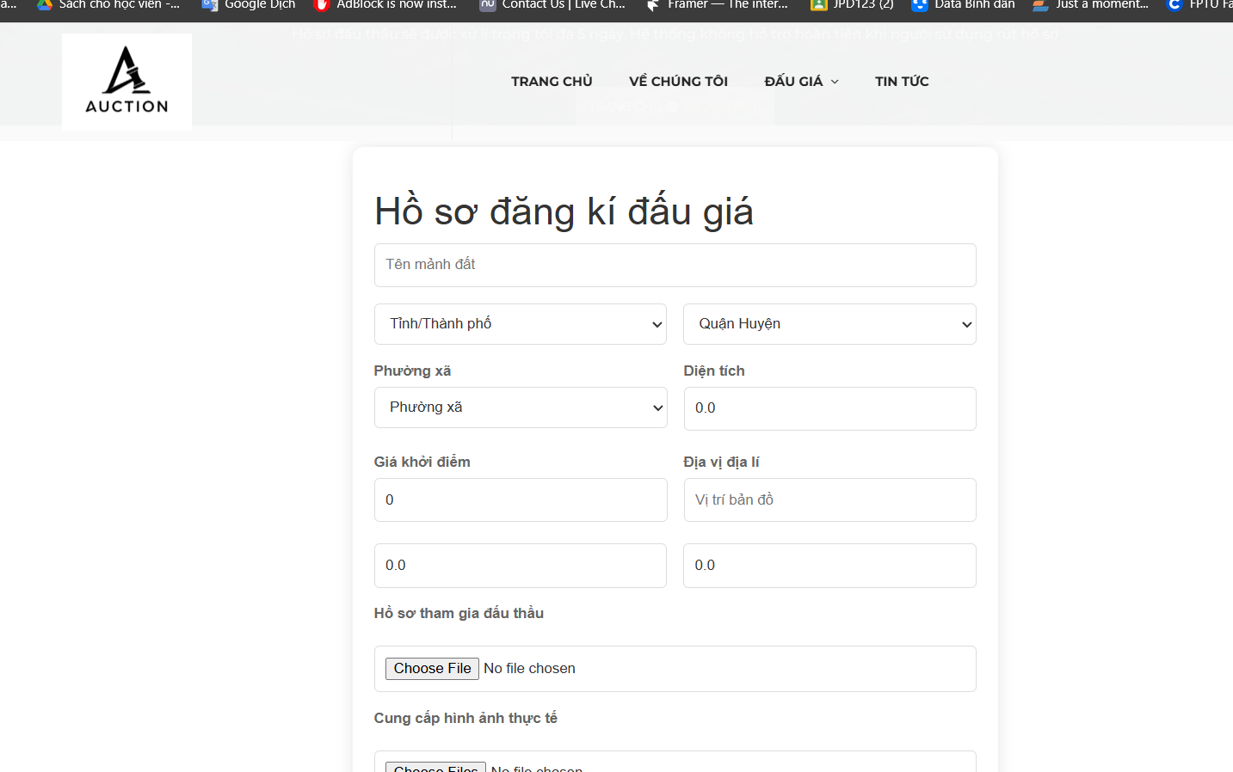

| **Field Name** | **Field Type** | **Description** |
| --- | --- | --- |
| ***Search Fields*** | | |
| Search Type | Select | User choose the news categories they want |
| Search Phase | Text | User enter the news’s name to search |
| Cancel | Button | Cancel asset register |
| ***Asset*** | | |
| Title | Text | News’s title |
| Cover photo | Image | News’s cover photo |
| Edit button | Button | Button redirect user to update news’s form |
| Delete button | Button | Button to delete news |
| ***Create asset*** | | |
| Create asset | Button | Click to open the Create asset page |

#### Database asset

#### 

| **Table** | **CRUD** | **Description** |
| --- | --- | --- |
| Asset | R | Get all Asset register that satisfy the search constraint from Asset table |

***SQL Commands:***

1/ Get all Auction that satisfy the search constraint from Auctiontable

SELECT a.title, a.name, a.description

FROM Asset a

WHERE a.userid = ?

### 1.16 View User profile

#### UI Design

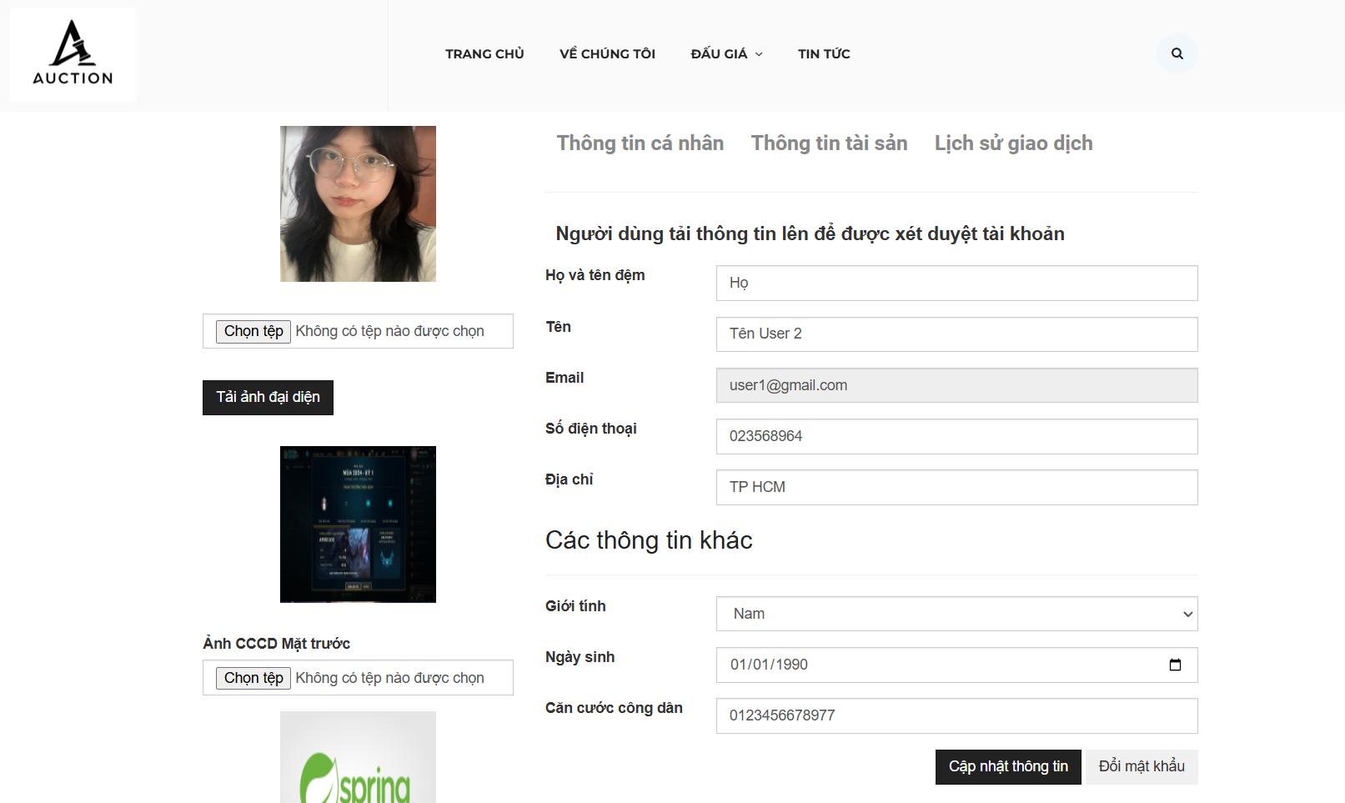

| **Field Name** | **Field Type** | **Description** |
| --- | --- | --- |
| UserName | Text | Display username of user |
| Avatar | Text | Display avatarof user |
| Password | Text | Display password of user |
| New Password | Text | Display new password of user |
| Confirm password | Text | Repate new password of username |
| Email | Text | Display email of user |
| Fullname | Text | Display full nameof user |
| Phonenumber | Text | Display Phonenumberof user |
| Date of birth | Text | Display Date of birth of user |
| Address | Text | Display Addressof user |
| Gender | Select | Display gender of user |
| Update buttion | Button | Button redirect user to update news’s information |
| Delete button | Button | Button to inactive user |

#### Database asset

#### 

| **Table** | **CRUD** | **Description** |
| --- | --- | --- |
| Auction | U, R | Get all information about user and change information. |

#### SQL Commands

1/ Get all information belong to user

SELECT *

FROM User a

WHERE a.userid = ?

### 1.19 Wishlist

#### UI Design

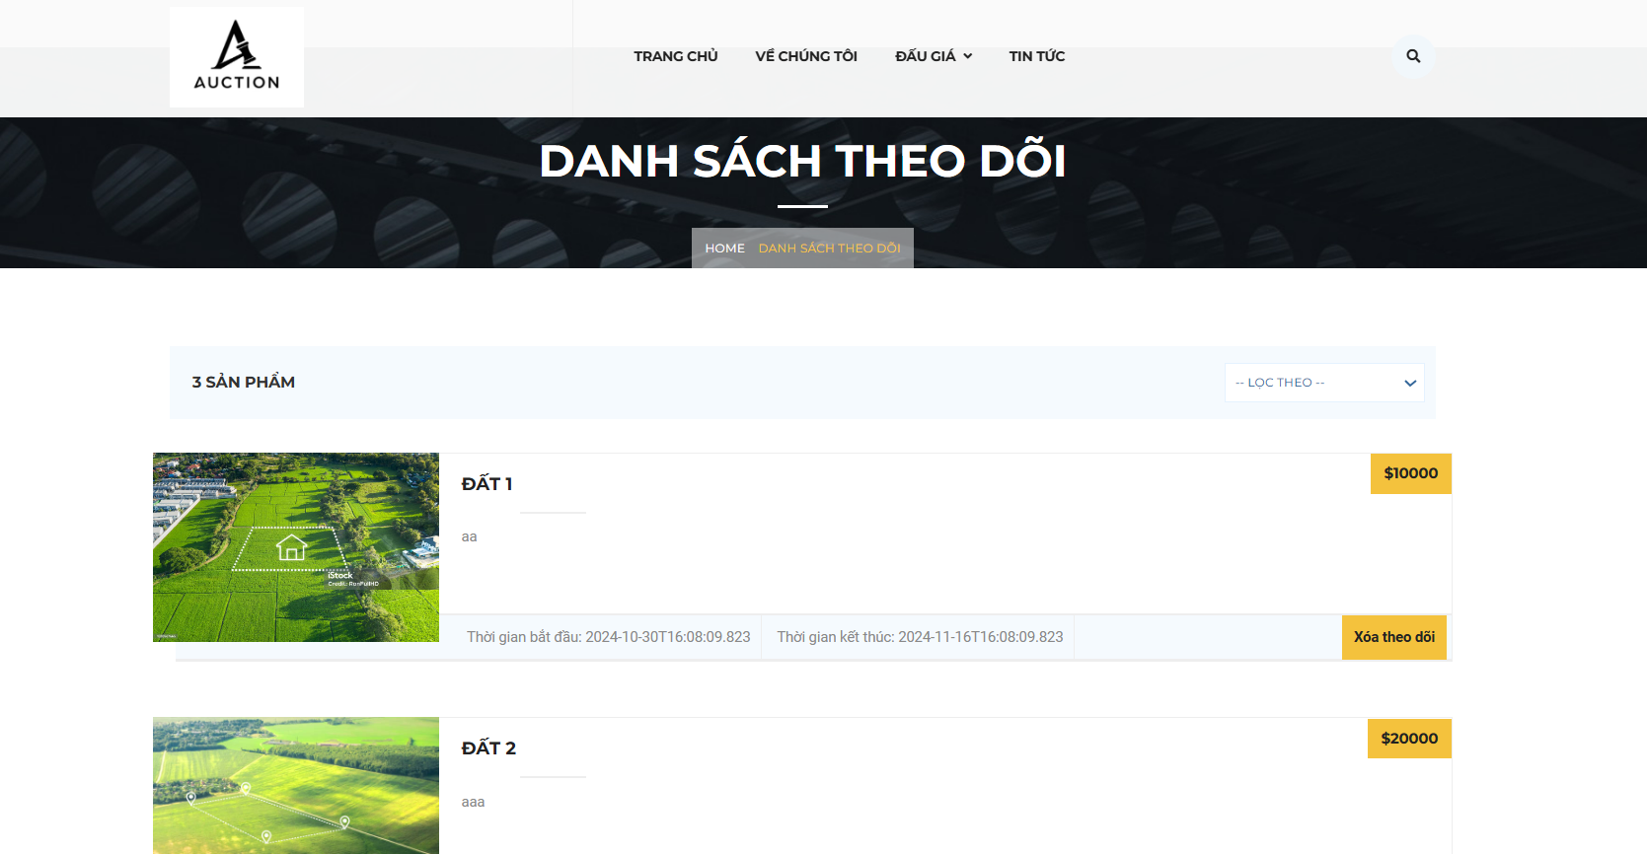

| **Field Name** | **Field Type** | **Description** |
| --- | --- | --- |
| ***Bidding history*** | | |
| User | Text | Username of all user in this session |
| Amount | Text | Money they bidded into the session |
| Date | Text | Time they make decision to bid |
| ***Bidding function*** | | |
| Current money | Text | Highest money bidded at the present |
| Amount bid | Text | Money user want to bid |
| Place bid | Button | Commit money into system |
| Plus | Button | Plus amount with step price |
| Minus | Button | Minus amount with step price |
| Auction session information | | |
| Status | Text | Whether session end or start |
| Time | Text | Time of session end |

#### Database asset

| **Table** | **CRUD** | **Description** |
| --- | --- | --- |
| Auction | R | Display auction history |
| Bid | C | Write bid amount information to store history of auction |

#### 

#### SQL Commands

### 1.20 Join ongoing auction

#### UI Design

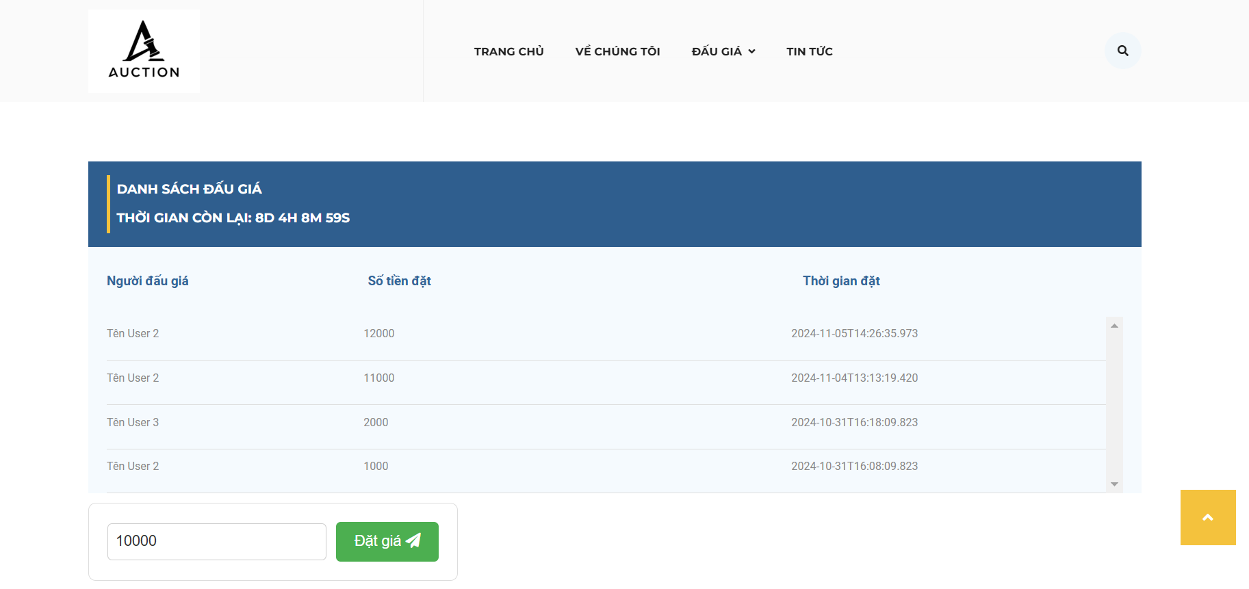

| **Field Name** | **Field Type** | **Description** |
| --- | --- | --- |
| ***Bidding history*** | | |
| User | Text | Username of all user in this session |
| Amount | Text | Money they bidded into the session |
| Date | Text | Time they make decision to bid |
| ***Bidding function*** | | |
| Current money | Text | Highest money bidded at the present |
| Amount bid | Text | Money user want to bid |
| Place bid | Button | Commit money into system |
| Plus | Button | Plus amount with step price |
| Minus | Button | Minus amount with step price |
| Auction session information | | |
| Status | Text | Whether session end or start |
| Time | Text | Time of session end |

#### Database asset

| **Table** | **CRUD** | **Description** |
| --- | --- | --- |
| Auction | R | Display auction history |
| Bid | C | Write bid amount information to store history of auction |

#### SQL Commands

Write transaction into wallet of user

Insert into Bid values

(amount, userid, date) where auctionid = ??

Select * from Auction A join Bid B on A.id = B.id

## 

### 1.21 Pay deposit winner

#### UI Design

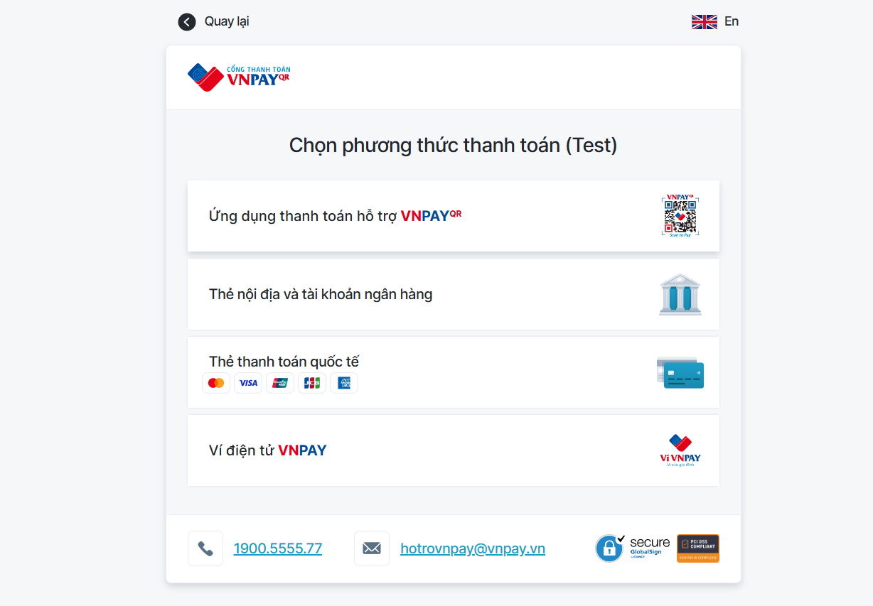

| **Field Name** | **Field Type** | **Description** |
| --- | --- | --- |
| Complete Deposit | Button | User’s pay asset deposit after become winner of this session |

#### Database asset

| **Table** | **CRUD** | **Description** |
| --- | --- | --- |
| Wallet | R | Write the deposit winner asset transaction for user |

#### SQL Commands

Write transaction into wallet of user

Insert into wallet

Values (transactionid, userid, amount, type, date)

## 

### 1.22 Pay auction registration fee

#### UI Design



| **Field Name** | **Field Type** | **Description** |
| --- | --- | --- |
| Complete fee | Button | User’s pay asset deposit before being able to join the auction session |

#### Database asset

| **Table** | **CRUD** | **Description** |
| --- | --- | --- |
| Wallet | R | Write the auction fee transaction for user |
| Auction_registration | R | Confirm user join the auction |
| Wallet | U | Minus balance of user wallet |

#### SQL Commands

Write transaction into wallet of user

Insert into wallet

Values (transactionid, userid, amount, type, date)

Insert into Auction_registration values

(userid, auctionid)

Update Wallet

Set balance = balance -500000

Where userid = ?

## 

### 1.24 Pay asset form

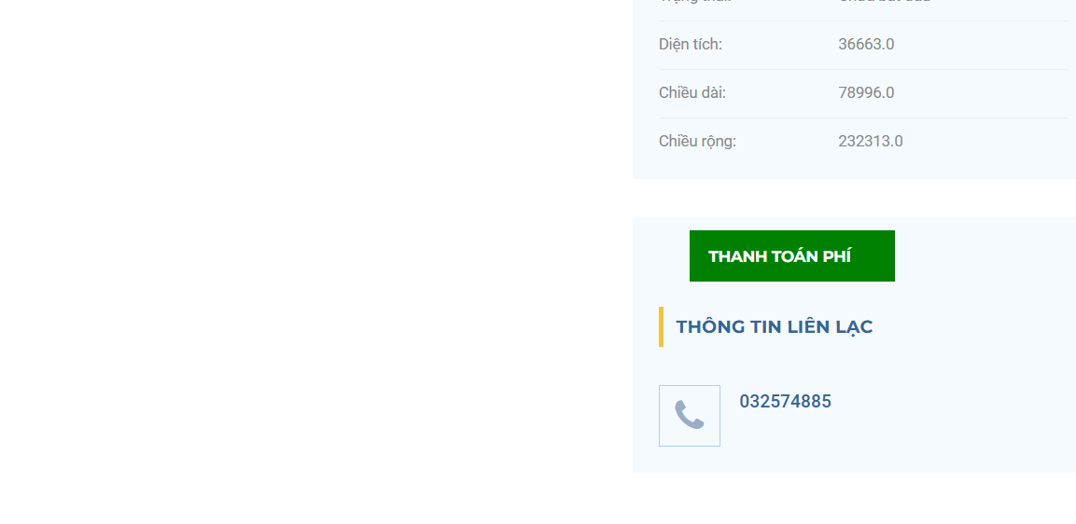

#### UI Design

| **Field Name** | **Field Type** | **Description** |
| --- | --- | --- |
| Complete fee | Button | User’s pay asset deposit before push asset into system |

#### Database asset

| **Table** | **CRUD** | **Description** |
| --- | --- | --- |
| Wallet | R | Write the auction fee transaction for user |
| Wallet | U | Minus balance of user wallet |

#### SQL Commands

Write transaction into wallet of user

Insert into wallet

Values (transactionid, userid, amount, type, date)

Update Wallet

Set balance = balance -500000

Where userid = ?

## 2. Customer care screen

### 2.1 View all news

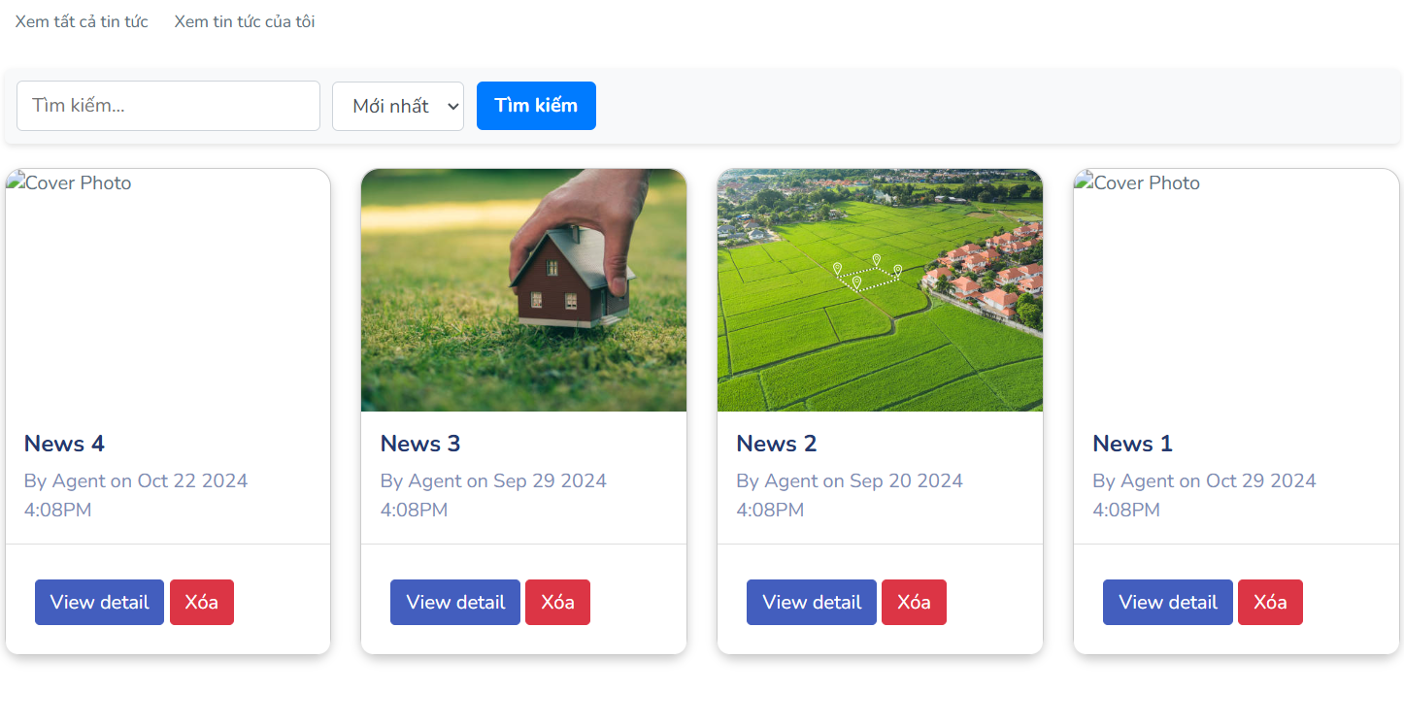

#### UI Design

| **Field Name** | **Field Type** | **Description** |
| --- | --- | --- |
| ***Search Fields*** | | |
| Search Type | Select | User choose the news categories they want |
| Search Phase | Text | User enter the news’s name to search |
| View all news | Button | Get all news that existing on the system for staff |
| View my own news | Button | Get all news that this staff is author |
| ***News*** | | |
| Title | Text | News’s title |
| Cover photo | Image | News’s cover photo |
| Edit button | Button | Button redirect user to update news’s form |
| Delete button | Button | Button to delete news |
| ***Create news*** | | |
| Create news | Button | Click to open the Create News page |

#### Database asset

| **Table** | **CRUD** | **Description** |
| --- | --- | --- |
| News | R | Get all news that satisfy the search constraint from News table |
| Tag_for_news | R | Get all tags for news |
| News_Tag_for_news | R | Get all tags of a specify news |

#### SQL Commands

1/ Get all news that satisfy the search constraint from News table

SELECT * FROM News n right join News_Tag_for_news nt on n.news_id = nt.news_id WHERE n.title LIKE %?% or nt.tag_id = ?

2/ Get all tags for news

SELECT * FROM Tag_for_news

3/ Get all tags of a specify news

SELECT * FROM News_Tag_for_news nt where nt.news_id = ?

### 2.2 View own news

#### UI Design

| **Field Name** | **Field Type** | **Description** |
| --- | --- | --- |
| ***Search Fields*** | | |
| Search Type | Select | User choose the news categories they want |
| Search Phase | Text | User enter the news’s name to search |
| View all news | Button | Get all news that existing on the system for staff |
| View my own news | Button | Get all news that this staff is author |
| ***News*** | | |
| Title | Text | News’s title |
| Cover photo | Image | News’s cover photo |
| Edit button | Button | Button redirect user to update news’s form |
| Delete button | Button | Button to delete news |
| ***Create news*** | | |
| Create news | Button | Click to open the Create News page |

#### Database asset

| **Table** | **CRUD** | **Description** |
| --- | --- | --- |
| News | R | Get all news of a specific author and satisfy the search constraint from News table |
| Tag_for_news | R | Get all tags for news |
| News_Tag_for_news | R | Get all tags of a specify news |

#### SQL Commands

1/ Get all news that satisfy the search constraint from News table

SELECT * FROM News n right join News_Tag_for_news nt on n.news_id = nt.news_id WHERE n.title LIKE %?% or nt.tag_id = ? AND n.staff_id = ?

2/ Get all tags for news

SELECT * FROM Tag_for_news

3/ Get all tags of a specify news

SELECT * FROM News_Tag_for_news nt where nt.news_id = ?

### 2.3 View news detail

#### UI Design

| **Field Name** | **Field Type** | **Description** |
| --- | --- | --- |
| ***News*** | | |
| Title | Text | News’s title |
| Cover photo | Image | News’s cover photo |
| Content | Text | News’s content |
| Created date | Button | News’s create date |
| Author | Text | News’s author |

#### Database asset

| **Table** | **CRUD** | **Description** |
| --- | --- | --- |
| News | R | Get the news that satisfy the news_id user selected |

#### SQL Commands

1/ Get the news that satisfy the news_id user selected

SELECT * FROM News n right join News_Tag_for_news nt on n.news_id = nt.news_id WHERE n.news_id = ?

### 2.4 Create news

#### UI Design

| **Field Name** | **Field Type** | **Description** |
| --- | --- | --- |
| ***News*** | | |
| Title | Text | News’s title |
| Cover photo | Image | News’s cover photo |
| Content | Text | News’s content |
| Tag | Checkbox | News’s tags |
| Save | Button | User click save button to save news into database |

#### Database asset

| **Table** | **CRUD** | **Description** |
| --- | --- | --- |
| News | C | Create news to News table |

#### SQL Commands

1/ Create news to News table

Insert into News (title, content, cover_photo_id, created_date, staff_id) values (?,?,?,?,?)

### 2.5 Update news

#### UI Design

| **Field Name** | **Field Type** | **Description** |
| --- | --- | --- |
| ***News*** | | |
| Title | Text | News’s title |
| Cover photo | Image | News’s cover photo |
| Content | Text | News’s content |
| Tag | Checkbox | News’s tags |
| Update | Button | User click save button to update news into database |

#### Database asset

| **Table** | **CRUD** | **Description** |
| --- | --- | --- |
| News | U | Update news to News table |

#### SQL Commands

1/ Update news to News table

Update News set title = ?, content = ?, cover_photo_id = ?, create_date = ?, staff_id = ? where news_id = ?

## 3. Staff Screen

### 3.6 View asset list

#### UI Design

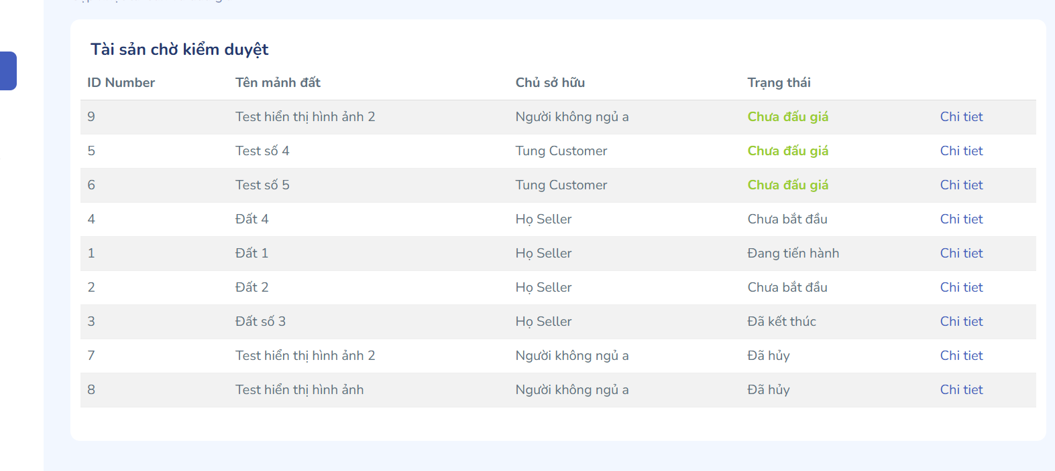

| **Field Name** | **Field Type** | **Description** |
| --- | --- | --- |
| ***Search Fields*** | | |
| Search type | Select | User choose the asset categories they want |
| Search phase | Text | User enter the asset’s name to search |
| ***Asset*** | | |
| Location | Text | Asset’s location |
| Asset image | Image | The first asset’s image |

#### Database asset

| **Table** | **CRUD** | **Description** |
| --- | --- | --- |
| Asset | R | Get all assets that satisfy the search constraint |
| Tag | R | Get all tags for asset |
| Asset_Tag | R | Get all tags of a specific asset |

#### SQL Commands

1/ Get all assets that satisfy the search constraint

SELECT * FROM Asset a right join Asset_Tag at on a.asset_id = at.asset_id WHERE a.location LIKE %?% or at.tag_id = ?

2/ Get all tags for asset

SELECT * FROM Tag

3/ Get all tags of a specific asset

SELECT * FROM Asset_Tag at where at.asset_id = ?

### 2.7 View asset detail

#### UI Design

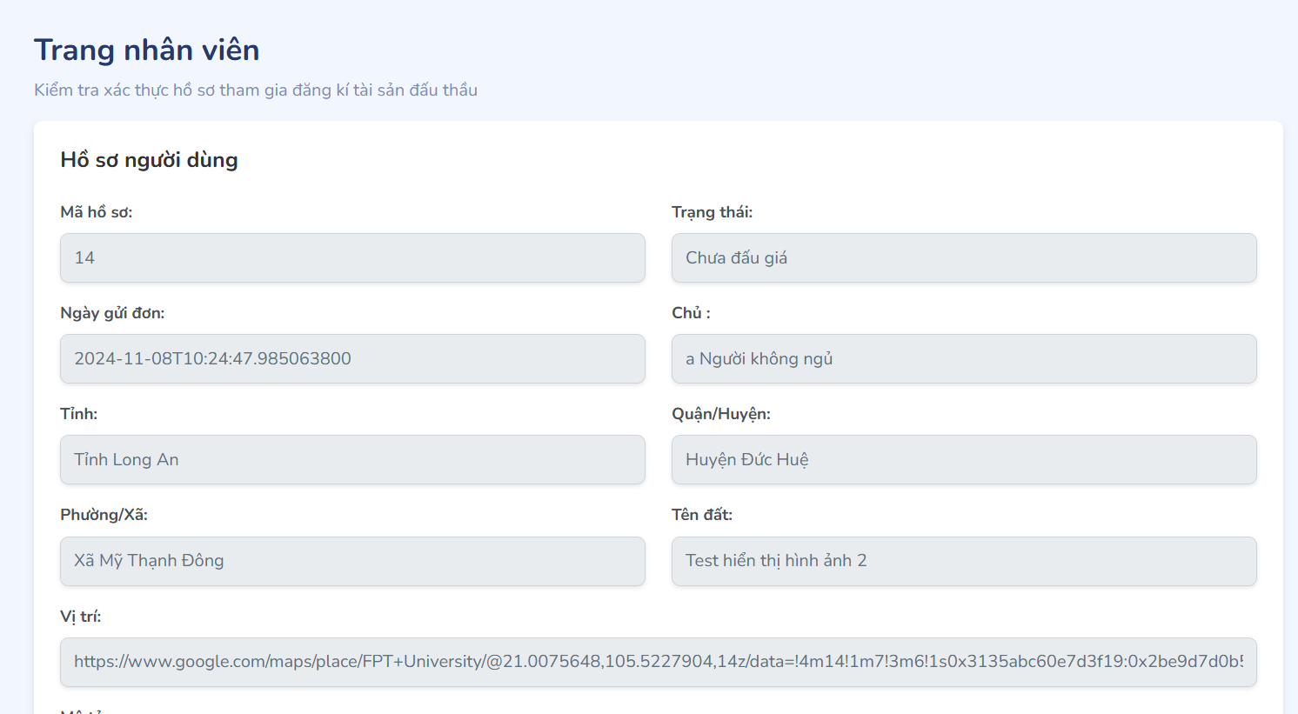

| **Field Name** | **Field Type** | **Description** |
| --- | --- | --- |
| ***Asset*** | | |
| Location | Text | Asset’s location |
| Length | Number | Asset’s length |
| Width | Number | Asset’s width |
| Area | Number | Asset’s area |
| Description | Text | Description about asset |
| Coordinate on map | Hyperlink | Position of asset on google map by URL sharing |
| Local authority | Text | Local authority where the asset is located |
| Status | Text | Asset status |
| Create date | Date | Asset created date |
| Asset image | File | Asset’s image |
| Asset document | File | Asset’s document |

#### Database asset

| **Table** | **CRUD** | **Description** |
| --- | --- | --- |
| Asset | R | Get the asset that satisfy the asset_id user selected |

#### SQL Commands

1/ Get all news that satisfy the search constraint from News table

SELECT * FROM Asset a WHERE a.asset_id = ?

### 2.8 View auction list

#### UI Design

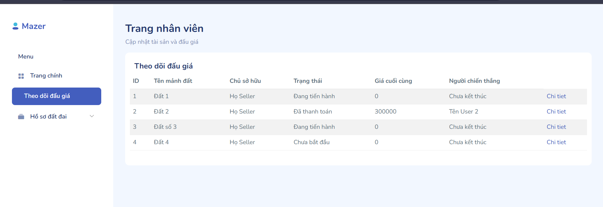

| **Field Name** | **Field Type** | **Description** |
| --- | --- | --- |
| ***Search Fields*** | | |
| Search type | Select | User choose the auction status they want |
| Search phase | Text | User enter the auction’s name to search |
| ***Auction*** | | |
| Auction name | Text | Auction’s name |
| Auction image | Image | The first auction’s image |
| Starting price | Number | Starting price of auction session |

#### Database asset

| **Table** | **CRUD** | **Description** |
| --- | --- | --- |
| Auction_session | R | Get all auction that satisfy the search constraint |

#### SQL Commands

1/ Get all auction that satisfy the search constraint

SELECT * FROM Auction

### 2.9 View auction detail

#### UI Design

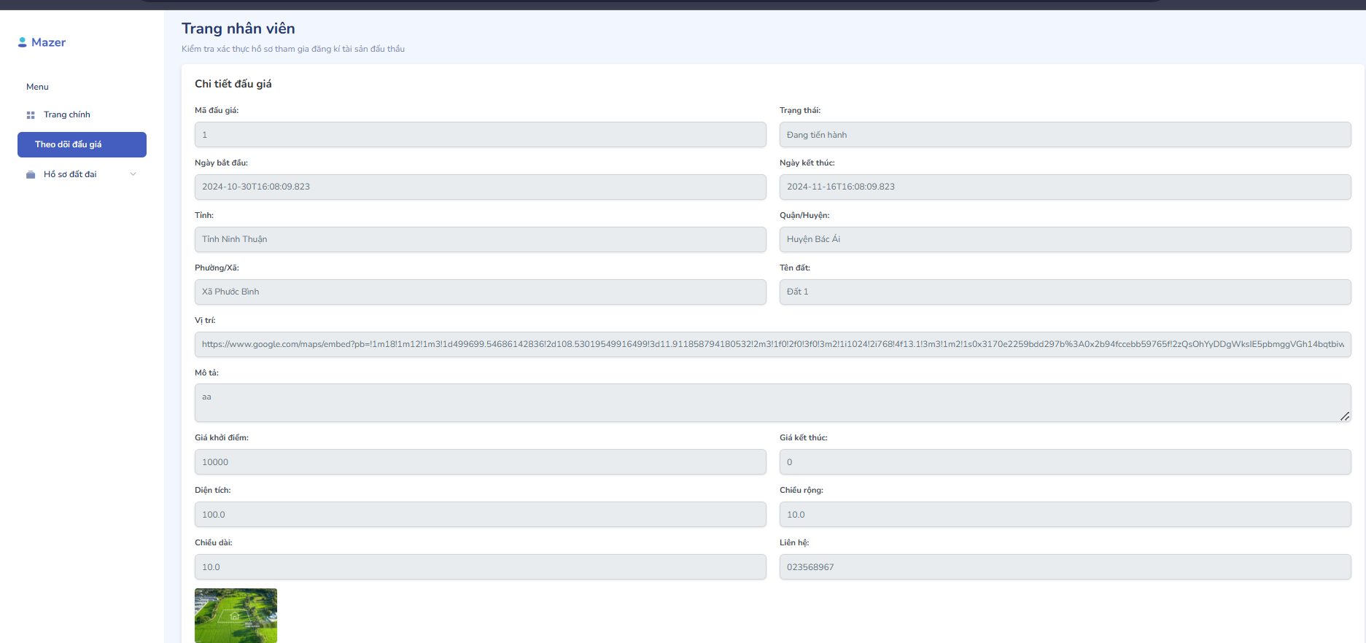

| **Field Name** | **Field Type** | **Description** |
| --- | --- | --- |
| ***Auction*** | | |
| Auction name | Text | Auction’s name |
| Start time | Date | Start time of auction session |
| Expected end time | Date | Expected end time of auction session |
| Actual end time | Date | Actual end time of auction session |
| Starting price | Number | Starting price of auction session, the bid price of customer must be larger than the starting price |
| Dealt price | Number | The final and highest price placed in an auction |
| Winner full name | Text | Full name of auction winner |
| Minimum bid increment | Number | Minimum price step between bids |
| Deposit | Number | Auction deposit, buyer must pay deposit when buy asset |
| Register fee | Number | Auction participation fee, buyers must pay a participation fee when registering to participate in the auction |
| Extra time unit | Number | Time is added when someone places a bid when the auction countdown falls below the set time |
| Status | Text | Auction status |
| Registration open date | Date | Time to open registration for auction |
| Registration close date | Date | Time to close registration for auction |
| Asset | Hyperlink | Link to asset detail page |
| Image | File | Asset image |
| Document | File | Asset document |
| ***Bid list*** | | |
| Register id | Number | Id of bidder |
| Register full name | Text | Full name of bidder |
| Amount | Number | The price of bidder |
| Create date | Date | Bid generation time |
| Next page | Button | Click to move to the next section of the list |
| Previous page | Button | Click to move to the previous section of the list |
| ***Register list*** | | |
| Register id | Number | Id of bidder |
| Register full name | Text | Full name of bidder |
| Email | Text | Email of bidder |
| Phone number | Text | Phone number of bidder |
| Register status | Text | One of the following statuses: not transfer, waiting confirm, confirmed |
| Action | Hyperlink | Click to move to register detail page |
| Next page | Button | Click to move to the next section of the list |
| Previous page | Button | Click to move to the previous section of the list |

#### Database asset

| **Table** | **CRUD** | **Description** |
| --- | --- | --- |
| Auction_session | R | Get all auction that has auction_id that user selected |
| Auction_register | R | Get all auction register of that auction session |
| Bid | R | Get all bid that be created in that auction session |

#### SQL Commands

1/ Get all auction that has auction_id that user selected

SELECT * FROM Auction a where a.auction_id = ?

2/ Get all auction register of that auction session

SELECT * FROM Auction_register ar where ar.auction_id = ?

3/ Get all bid that be created in that auction session

SELECT * FROM Bid b left join Auction_register ar on b.register_id = ar.register_id where ar.auction_id = ?

### 2.10 View asset awaiting scheduling list

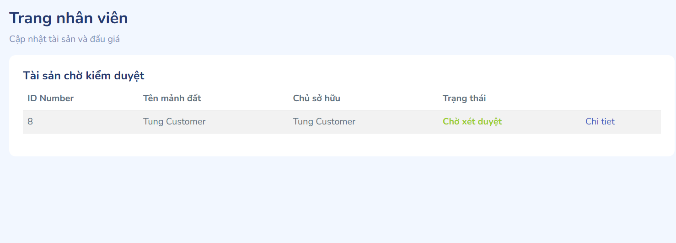

#### UI Design

| **Field Name** | **Field Type** | **Description** |
| --- | --- | --- |
| ***Search Fields*** | | |
| Search type | Select | User choose the asset categories they want |
| Search phase | Text | User enter the asset’s name to search |
| ***Asset*** | | |
| Location | Text | Asset’s location |
| Asset image | Image | The first asset’s image |

#### Database asset

| **Table** | **CRUD** | **Description** |
| --- | --- | --- |
| Task | R | Get all auction that has auction_id that user selected |
| Auction_register | R | Get all auction register of that auction session |
| Bid | R | Get all bid that be created in that auction session |

#### SQL Commands

1/ Get all auction that has auction_id that user selected

SELECT * FROM Auction a where a.auction_id = ?

2/ Get all auction register of that auction session

SELECT * FROM Auction_register ar where ar.auction_id = ?

3/ Get all bid that be created in that auction session

SELECT * FROM Bid b left join Auction_register ar on b.register_id = ar.register_id where ar.auction_id = ?

### 2.11 Validate asset

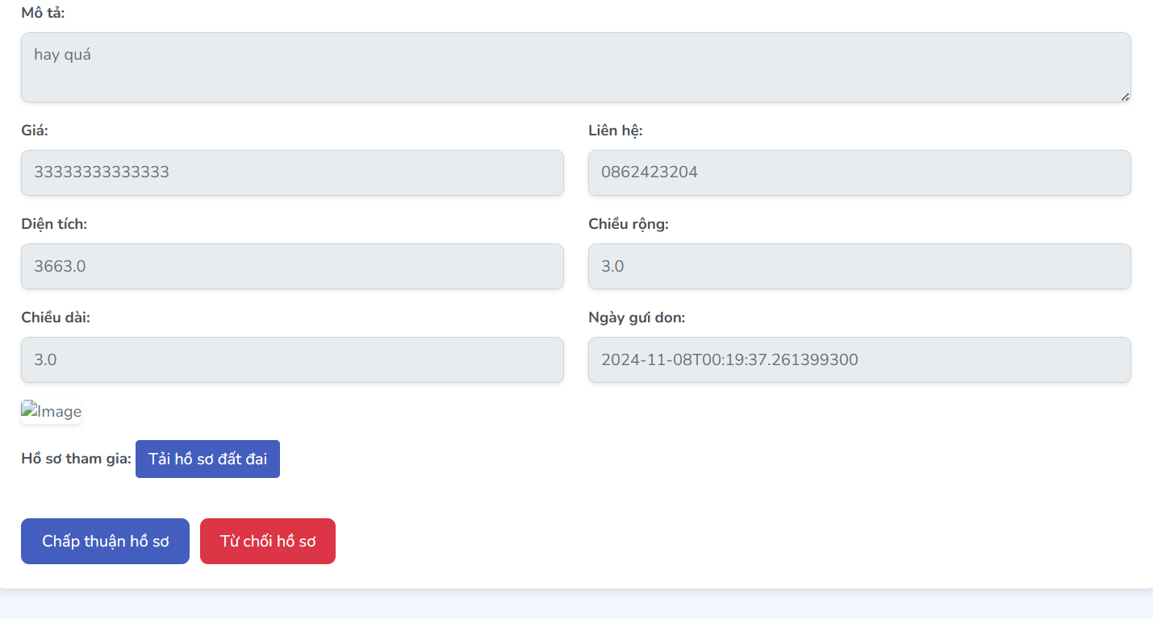

#### UI Design

| **Field Name** | **Field Type** | **Description** |
| --- | --- | --- |
| Location | Text | Asset’s location |
| Length | Number | Asset’s length |
| Width | Number | Asset’s width |
| Area | Number | Asset’s area |
| Description | Text | Description about asset |
| Coordinate on map | Hyperlink | Position of asset on google map by URL sharing |
| Local authority | Text | Local authority where the asset is located |
| Status | Text | Asset status |
| Create date | Date | Asset created date |
| Asset image | File | Asset’s image |
| Asset document | File | Asset’s document |
| Accept button | Button | Click to validate asset and show Schedule auction popup |
| Denied button | Button | Click to denied asset |

#### Database asset

| **Table** | **CRUD** | **Description** |
| --- | --- | --- |
| Asset | R, U | Get all asset’s information of an asset with selected asset_id and change the asset_status |

#### SQL Commands

1/ Get all asset’s information of an asset with selected asset_id

Select * from Asset where asset_id = ?

UPDATE Asset SET asset_status = ‘Awaiting for scheduling’ WHERE asset_id = ?

### 2.12 Schedule auction

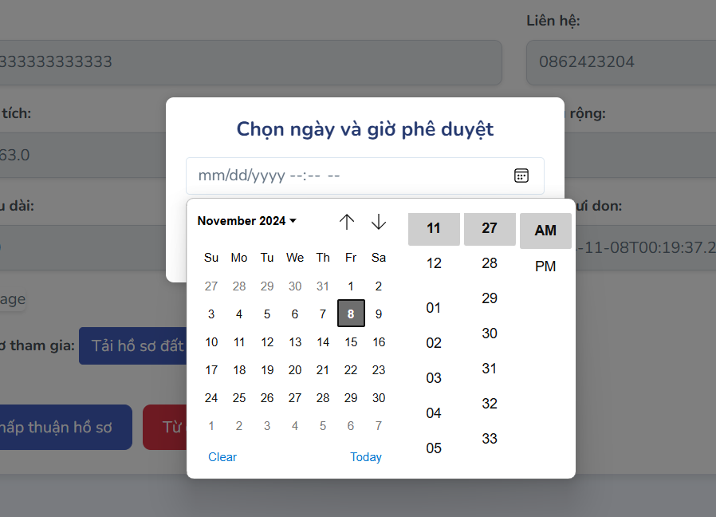

#### UI Design

| **Field Name** | **Field Type** | **Description** |
| --- | --- | --- |
| ***Asset*** | | |
| Location | Text | Asset’s location |
| Length | Number | Asset’s length |
| Width | Number | Asset’s width |
| Area | Number | Asset’s area |
| Description | Text | Description about asset |
| Coordinate on map | Hyperlink | Position of asset on google map by URL sharing |
| Local authority | Text | Local authority where the asset is located |
| Status | Text | Asset status |
| Create date | Date | Asset created date |
| Asset image | File | Asset’s image |
| Asset document | File | Asset’s document |
| ***Auction*** | | |
| Auction name | Text | The name of auction for this asset |
| Starting price | Number | The starting price for this auction |
| Minimum bid increment | Number | The minimum bid increment between bids |
| Deposit | Number | The deposit buyer must pay before buying this asset |
| Register fee | Number | The register fee buyer must pay to register this auction |
| Extra time unit | Number | Seconds added when someone bids when the remaining time of the auction is less than this value |
| Registration open date | Date | Auction registration opening date |
| Registration close date | Date | Auction registration close date |
| Start time | Date | Auction start time |
| Expected end time | Date | Auction expected end time |

#### Database access

| **Table** | **CRUD** | **Description** |
| --- | --- | --- |
| Asset | R, U | Get all asset’s information of an asset with selected asset_id and update this asset_status when form is submitted |
| Auction_session | C | Create auction session with the information submitted in the form for that asset |

#### SQL Commands

1/ Get all asset’s information of an asset with selected asset_id

Select * from Asset where asset_id = ?

UPDATE Asset SET asset_status = 'Awaiting auction’ WHERE asset_id = ?

2/ Create auction session with the information submitted in the form for that asset

Insert into Auction_session (auction_name, start_time, expected_end_time, starting_price, minimum_bid_increment, deposit, register_fee , extra_time_unit ,status, registration_open_date, registration_close_date, asset_id,auctioneer_id) values (?,?,?,?,?,?,?,?,”Upcoming”,?,?,?,?)

## 3. Admin’s screen

### 3.1 Staff’s Account Management

#### UI Design

| **Field Name** | **Field Type** | **Description** |
| --- | --- | --- |
| Search box | Text field | User input keyword, name of the username to search. |
| Status filter | Select | Filter out account’s according to the status. |
| Order by | Select | Sort the records in the table follow a specific order. |
| Create new account | Button | Click to create a new account. |
| Table view | | |
| ID | Integer | The id of the account. |
| Username | text | Username of the account. |
| Email | Text | Email of the account. |
| Phone number | Text | The phone number of the account. |
| Status | Text | The status of the account. |
| Option | Hyperlink | The link to view details of the account. |
| Pagination | | |
| Previous << | Button | Click to go to the previous page of the result. |
| Next >> | Button | Click to go to the next page of the result. |

#### Database access

#### 

| **Table** | **CRUD** | **Description** |
| --- | --- | --- |
| Account | R | Get the basic information of account |

#### SQL commands

SELECT a.id,

a.username,

a.email,

a.phone_number

a.status

FROM Account a

WHERE a.role_id = ;

### 3.2 User’s Account Management

#### UI Design

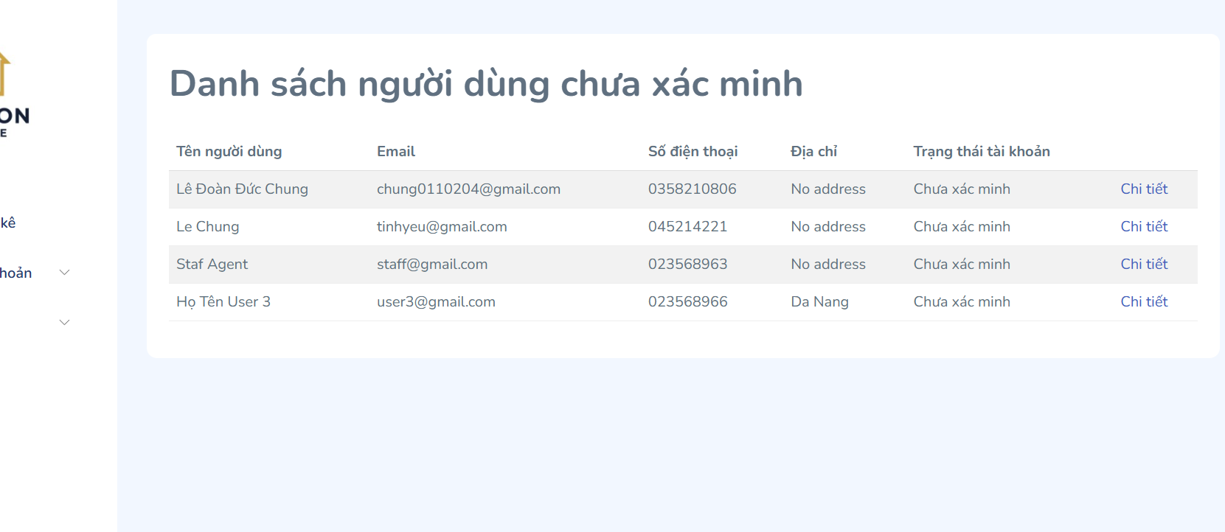

| **Field Name** | **Field Type** | **Description** |
| --- | --- | --- |
| Search box | Text field | User input keyword, name of the username to search. |
| Status filter | Select | Filter out account’s according to the status. |
| Order by | Select | Sort the records in the table follow a specific order. |
| Create new account | Button | Click to create a new account. |
| Table view | | |
| ID | Integer | The id of the user. |
| Username | text | Username of the user. |
| Email | Text | Email of the user. |
| Phone number | Text | The phone number of the user. |
| Status | Text | The status of the user. |
| Option | Hyperlink | The link to view details of the user. |
| Pagination | | |
| Previous << | Button | Click to go to the previous page of the result. |
| Next >> | Button | Click to go to the next page of the result. |

#### Database access

#### 

| **Table** | **CRUD** | **Description** |
| --- | --- | --- |
| Account | R | Get the basic information of user |

#### SQL commands

SELECT a.id,

a.username,

a.email,

a.phone_number

a.status

FROM Account a

WHERE a.role_id = ;

### 3.4 Create staff account

#### UI Design

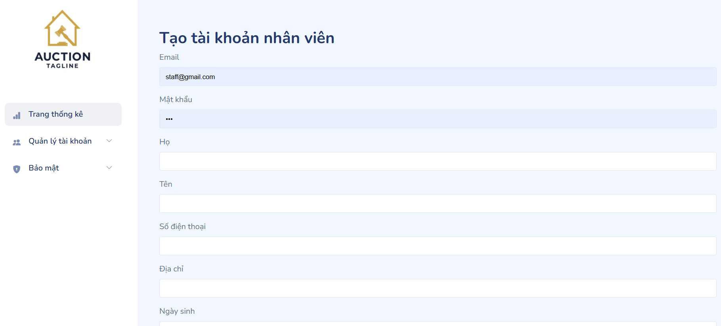

| **Field Name** | **Field Type** | **Description** |
| --- | --- | --- |
| ID | Integer | The id of the user. Can’t modify this, this will be generated automatically in the database. |
| Avatar | Text field | The staff could upload an image so that it will be the account’s avatar. |
| Username | text | Username of the user. Staff can update this field. |
| Status | Select box | The status of the account. Staff can update this field. |
| Email | Text | Email of the user. Staff can update this field. |
| Role | Select box | The role of the account. Staff can update this field. |
| Fullname | Text | The full name of the user. Staff can update this field. |
| Phone number | Text | The phone number of the user. Staff can update this field. |
| Date of birth | Date | The date of birth of the user. Staff can update this field. |
| Address | Text | The address of the user. Staff can update this field. |
| Gender | Select box | The gender of the user. Staff can update this field. |
| Tax identification | Text | The tax identification of the user. Staff can update this field. |
| Personal identification number | Text | The personal identification number of the user. Staff can update this field. |
| Bank name | Select box | The bank name that the user’s bank account belongs to. Staff can update this field. |
| Create | Button | Click to update the account’s details. |

#### Database access

#### 

| **Table** | **CRUD** | **Description** |
| --- | --- | --- |
| Account | C | Create new account |
| Profile | C | Create profile of the account |

#### SQL commands

INSERT INTO Account ( account_id, username, password, status, verify, email, avatar_image_id, role_id, registration_date, balance ) VALUES ();

INSERT INTO Profile ( account_id, full_name, gender, date_of_birth, address, phone_number, tax_identification_number, citizen_identification, id_issuance_date, id_issuance_place, id_card_front_image_id, id_card_back_image_id, bank_account_number, bank_name, bank_branch, bank_owner ) VALUES ();

#### 

# IV. Appendix

## 1. Assumptions & Dependencies

### 1.1 Assumptions

**AS-1**: The LandAuction website will be developed using modern web technologies, including but not limited to HTML, CSS, JavaScript, and a suitable backend framework (e.g., Spring Boot).

**AS-2**: Users, including guests, customers, staff, and admins, will have access to reliable internet connections and modern web browsers that support the website's features.

**AS-3**: All necessary third-party APIs and services (e.g., payment gateways like VNPAY) will be available and functional during both development and production phases.

**AS-4**: The development team has the required skills and experience to implement secure authentication, authorization, and data handling practices, especially concerning sensitive user and payment information.

**AS-5**: Adequate resources (e.g., developers, designers, testers) will be available throughout the project lifecycle to ensure the project is delivered on time.

**AS-6**: The hosting environment will provide sufficient performance, reliability, and security to handle the anticipated user traffic and ensure stable real-time auction sessions.

**AS-7**: All stakeholders, including auction managers and administrative staff, will provide timely feedback and approvals to avoid delays in the development process.

**AS-8**: The asset catalog, including properties available for auction, will be regularly updated and maintained by property managers.

**AS-9**: Users will follow the provided guidelines for creating accounts, participating in auctions, and managing their profiles to maintain system integrity and security.

### 1.2 Dependencies

**DE-1**: The project relies on a secure and reliable payment gateway (e.g., VNPAY) for processing auction-related transactions. The integration must be seamless and compliant with industry security standards.

**DE-2**: The hosting provider must offer a robust infrastructure to support the LandAuction website, including uptime guarantees, security measures, and scalability options to handle peak auction times.

**DE-3**: Third-party libraries and frameworks used in the project (e.g., Spring Boot, Hibernate, Thymeleaf) must be compatible with each other and actively maintained to prevent technical debt and security vulnerabilities.

**DE-4**: The project depends on reliable third-party APIs for services like email notifications (e.g., JavaMailSender for auction registration, bid confirmations, and password reset emails).

**DE-5**: Content Delivery Network (CDN) services may be used to ensure fast and reliable delivery of static assets (e.g., property images, CSS, JavaScript) to users across different geographical locations.

**DE-6**: The project requires collaboration with a domain registrar and SSL certificate provider to ensure the website’s domain is accessible and secure, providing users with confidence in site security.

**DE-7**: Integration with analytics tools (e.g., Google Analytics) is necessary to monitor website performance, user engagement, and traffic sources, which aids in optimizing the auction experience.

**DE-8**: The project relies on compliance with data protection regulations (e.g., GDPR) to ensure user data is handled securely and legally, respecting users’ privacy rights.

**DE-9**: Partnerships with real estate agencies and property managers are essential to maintain an up-to-date catalog of auction assets and facilitate timely, accurate listings.

## 2. Limitations & Exclusions

* Multiple payment gateway (VNPay only)
* Multiple language supporting
* Compatibilities checking system
* Verify user’s personal information automatically
* Update asset’s information continuously
* Customize suggestion for each individual customer

## 3. Business Rules

| **ID** | **Category** | **Rule Definition** |
| --- | --- | --- |
| BR1 | Constraint | Each user must have a unique username. |
| BR2 | Constraint | The image format must be: JPG, JPEG, PNG. The image size should not exceed 5MB. The minimum width of the image is 800px, and the maximum width is 1920px. |
| BR3 | Constraint | The password must meet security requirements. |
| BR4 | Constraint | The guest can’t sign up for a new user account if the below cases... |
| BR5 | Constraint | Only users who have successfully registered an account on the platform are allowed to place bids on auction items. |
| BR6 | Constraint | The bid amount must be greater than the current highest bid by at least the set minimum increment amount to be considered valid. |
| BR7 | Constraint | All legal documents must be in valid formats (PDF, DOCX) and under 10MB. |
| BR8 | Fact | Auction sessions should be displayed in descending order of date. |
| BR9 | Inference | Available staff is a staff that can chat with less than 8 customers at a time. |
| BR10 | Action Enabler | All documents must be reviewed and verified for legality and accuracy before approving the asset. |
| BR11 | Action Enabler | The system should log the reason for banning and the Admin who performed the action. |
| BR12 | Action Enabler | The system should log the unban action, including the Admin who performed the action and the reason for unbanning. |
| BR13 | Constraint | The customer can not join an auction session if his/her account is not valid |
| BR14 | Constraint | The customer can not join an auction session if he/she has not transferred register fee |

## 4. Exception list

| **ID** | **Description** | **Message** |
| --- | --- | --- |
| E001 | Data does not exist in database | Not exist data |
| E002 | Input data not correct format | Format not correct |
| E003 | User enter not valid data | Not valid data |
| E004 | Communication with the server failed | Server error |
| E005 | Documents data has not been verified | Not Verified |
| E006 | Session timeout automatically logout | Session timeout |
| E007 | Bid must not higher at least X than current bid | Bid must higher |
| E008 | Input not full blank information form | Missing input data |
| E009 | Asset cannot cancel at this stage | Can't do this in this stage |
| E010 | Data already in the database | Already data |
| E011 | Must log in to use this function | You must log in to continue. |
| E012 | User account must be validated before he/she could join an auction or make an asset validation request. | You must verify your account to continue. |
| E013 | This account is not allowed to access this site. | Account no access |
| E014 | Auction has ended or going on user is not allowed to access | Auction has ended, or going on |
|  |  |  |
|  |  |  |
|  |  |  |